EVOCA Tabletop Freshly Ground Coffee Machine General Operating Instructions

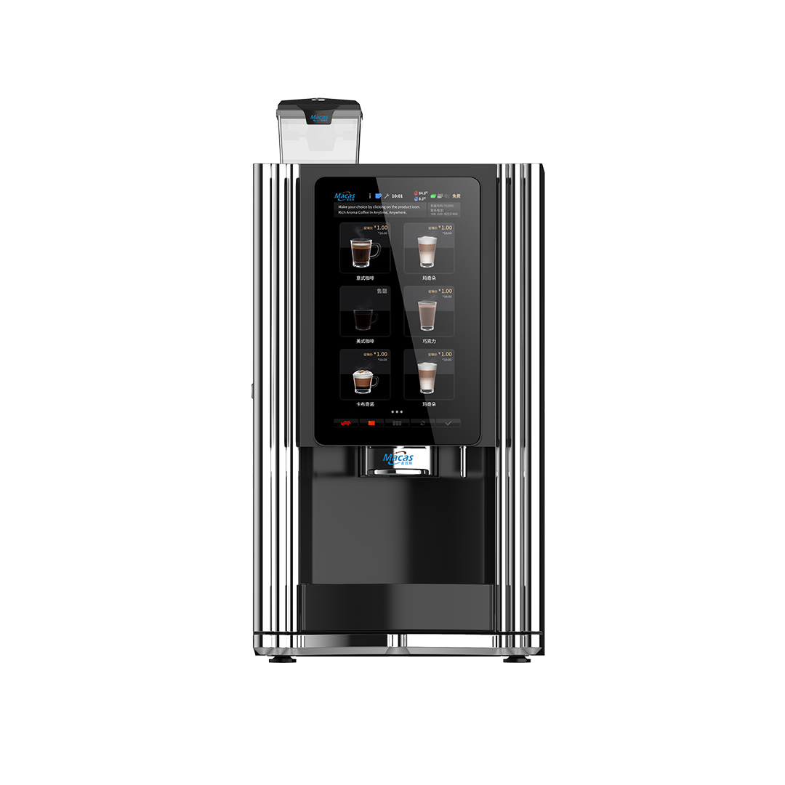

Guangzhou Evoacas Intelligent Equipment Co.,Ltd.

Address: 5th Floor, Building A1, Block B, No. 18, Road 7, Pacific Industrial Zone, Xintang Town, Zengcheng District, Guangzhou China

Email: kevin@icoffee-tea.com

Website:http://www.icoffee- tea.com

Call: 86-020-82557460

Directory

1 Preface 5

1.1 About the brochure 5

1.2 Important security advice 5

1.3 Wear and tear parts 6

1.4 Packaging material handling 6

1.5 Machine scrapping 7

1.6 Edition right 7

1.7 Statement 7

2 About the machine 8

2.1 features 8

2.1.1 Machines 8

2.1.2 Software and hardware pieces 8

2.1.3 Machine key indicators 9

2.1.4 Warehouse storage 9

2.1.5 Implementation standards 9

2.1.6 Machine installation 9

2.1.7 Machine capacity parameters 10

2.4 Front view o fthe external structure of the product 11

2.5 View of the product's internal structure 12

2.6 View of the hardware architecture and wiring on the back of the product 13

2.7 User Interface 14

2.8 Machine configuration 15

2.8.1 Configuration layout (canbe adapted to customer requirements) 15

2.9 Machine water circuit schematic (for reference only) 15

3 Transport and storage 16

3.1 Shipping Transport 16

3.2 Transport and storage environment 16

3.3 Machine shutdown 16

4 Pre-operational preparation 17

4.1 Placement of machines 17

4.2 Payment Systems 17

4.3 Water source 17

4.4 Product Formulation Setup 17

4.5 User definitions 17

5 Machine Installation 18

5.1 Unpacking 19

5.2 Machine opening 19

5.2.1 Machine back office maintenance interface 20

5.3 Connecting to a water sour 22

5.4 Filled instant powder canisters 22

5.5 Placement of waste bins and drip trays 23

5.6 Connecting the router,wifi and RJ45 23

5.7 Connect power and turn on 24

5.8 Filling boilers 25

5.9 Commissioning machines 25

5.9.1 Calibrated grinder 25

5.9.2 Calibrated instant cartridges 31

5.10 Setting the machine's vending mode 34

5.11 Beverage recipe setting 37

5.12 Beverage price setting 39

5.12.1 Beverage selling price setting 40

5.12.2 Different prices for different time periods 41

5.13 Automatic machine cleaning settings 42

6 Turnover & Accounts 43

7 Machine function options 44

8 Consumer use of the machine 47

9 Cleaning and maintenance 49

9.1 Safety regulations for cleaning and washing 49

9.2 Cleaning 50

9.3 Spoiled food 50

9.4 Cleaning Solutions 50

9.5 Basic cleaning work 50

9.6 Cleaning and guidelines 51

9.6.1 Opening and closing doors 51

9.6.2 Cleaning instant material box 52

9.6.3 Cleaning the agitator 53

9.6.4 Clean drink spout and holder 54

9.6.5 Clean coffee brewer 55

9.6.6 Cleaning the drip tray 61

9.6.7 Maintenance Guidelines 61

10 Procedures 63

10.1 System Backup 63

10.2 System Upgrade 63

10.3 System Recovery 63

11 Machine Certification 64

12 List of frequently asked questions 65

、

# 1 Preface

Thank you for purchasing a MACES4C fully automatic commercial freshly ground coffee maker! Please make sure you have notified EVOCA in advance about the factory settings, such as WeChat payment corporate account, Alipay corporate account, service phone number and company website, your company logo, recipe requirements and cup size and other important information.

## 1.1 About the brochure

This manual is an instructional document for authorized technicians to safely transport, install, set up, program, maintain and repair the machine. Please refer to the separate sections for guidelines on service, use and daily cleaning tasks.

The following is a description of the risk level.

|  |  |
| --- | --- |
| Description | Symbols |
| Risk of serious injury | Danger! |
| Risk of Injury | Caution! |
| Risk of machine damage | Attention:Beware |
| Risk of impaired machine function | Important:Important |
| Advice and recommendation | Note: Remarks |

McKays will not be liable for any personal injury or damage to the machine during transportation, installation, setup, programming, maintenance of the machine and use of spare parts, if not done in accordance with the instructions for irregular or careless operation.

Any alterations or structural adjustments to the machine are strictly prohibited, and in these cases, McKays will not exclude non-cash claims.

Only products and recipes approved by McKays may be used in the machine and McKays will not be liable for any damage caused thereby, the risk lies with the person operating the machine.

Always follow the instructions in the technical and user manuals; pictograms, symbols and instruction stickers attached to the machine must not be torn or removed.

The person setting up the machine needs to be a trained technician to do so; technical specifications of the product must not be changed

Caution.

## 1.2 Important security advice

1.Read this manual carefully before use!

2.Please refer to the nameplate to use the correct voltage.

3.Never store or use the machine near a heat or gas source!

4.The equipment must be disconnected before cleaning or maintenance!

5.Prevent the machine from being splashed!

6.Don't drag the cable when you unplug it!

7.Do not put the machine and cables into the water!

8.If the water hardness is high, greater than 8°DH, use a filter.

9.When the machine is installed and arranged, please be careful not to tilt, and do not let small children beside or touch the machine until the installation is completed.

10.If the cable is damaged, please contact EVOCA as soon as possible to purchase a new replacement part.

11.Please note the repair recommendations and intervals!

12.Protect the machine from the weather! (e.g. rain, low temperature, etc.)

13.It is strictly forbidden to use the machine outdoors!

14.Repairs, cleaning and restoration are to be done by trained or McCallister-trained service personnel!

15.For your own safety, and to ensure the longevity of your machine, we recommend that you use only original parts!

## 1.3 Wear and tear parts

Please note that this machine has parts that need to be replaced due to wear and tear even with proper cleaning and maintenance. This applies mainly to mechanical parts and parts of the hot water system, such as hoses, seals, etc.

Defects caused by wearing parts are not covered by warranty! Defects and malfunctions must be resolved by factory-trained technical service personnel by contacting your specialist retailer or the EVOCA after-sales service center.

## 1.4 Packaging material handling

The packaging materials include the following: cardboard, corrugated cardboard, treated wood, polystyrene components and plastic film.

After installation, please contact your local public cleaning service to dispose of packaging materials in a recyclable or environmentally friendly manner whenever possible.

## 1.5 Machine scrapping

End-of-life machines cannot be returned to the original factory. End-of-life machines contain materials that are harmful to the environment, especially electronic parts, so please dispose of them according to national standards!



## 1.6 Edition right

1.EVOCA, MACAS are trademarks or registered trademarks of Guangzhou Evoacas Intelligent Equipment Co.,Ltd. Other trademarks, product names, service names, and company names appearing in this manual and in the products described herein are the property of their respective owners.

2.This manual is copyrighted by the Company and all rights to this manual are reserved. No part of this manual may be modified, reproduced or transmitted in any form (electronic, photocopying or otherwise) without the written permission of the Company.

## 1.7 Statement

1.EVOCA is not responsible for any personal injury or damage to the machine during transportation, installation, setup, programming, maintenance of the machine and use of spare parts if not done in accordance with the instructions for irregular or careless operation.

2.Any changes and structural adjustments to the machine are strictly prohibited and in these cases, EVOCA will not exclude non-cash claims.

3.Only products and formulas approved by EVOCA can be used in the machine, and EVOCA does not assume any responsibility for any resulting losses; the risk lies with the person operating the machine.

4.Always follow the instructions in the technical and user manuals; pictograms, symbols and instruction stickers attached to the machine must not be torn or removed.

5.The person setting up the machine needs to be a trained technician to do so; no changes to the technical specifications of the product are allowed.

6.The product specifications and pictures mentioned in this manual are for machine reference only, the content will be modified at any time according to the actual situation, Guangzhou EVOCA Electronic Technology Co. We reserve the right of final interpretation!

# 2 About the machine

## 2.1 features

### 2.1.1 Machines

1.External dimensions: 960 (H) x 560 (L) x 600(W )( unit: mm) ;

2.Weight: 47 kg ~ 53 kg (without optional modules);

3.Mechanical locks;

4.Mouthpiece cup stand (place for cups);

5.Maximum cup height: 110mm;

6.Minimum cup height: 70mm.

### 2.1.2 Software and hardware pieces

1.15.6" touchscreen;

2.Communication methods: USB, RFID, WIFI, 4G (optional);

3.Data standards according to European EVA-DTS;

4.Wastewater tray full water sensing;

5.Wastewater tray position sensing;

6.Coffee bean cassette without bean test;

7.All actuatable components, e.g. valves, motors, etc. blocked overcurrent protection, wire break detection, status reporting;

8.Self-test on start-up, water system cut-off alarm;

9.Dose adjustable in the background;

10.Intelligent machine maintenance systems;

11.Daily automatic cleaning;

12.Fully automatic primary descaling (adding pills);

13.Fully automatic removal of the residual powder from the grinder on alternate days;

14.Graphical tool for beverage product configuration and machine configuration;

15.Highly flexible process parameter configuration adjustment tool for beverages;

16.Multi-language support;

17.Multimedia advertising broadcast;

18.BACK-OFFICE-SYSTEM:

EVA-DTS;

Product price setting;

Selling statistics;

Machine status monitoring;

### 2.1.3 Machine key indicators

1.Individual instant drink time 20 seconds (120ml);

2.Single Espresso coffee 40 sec (30ml) (brewed 35 sec);

3.Hot water output rate 20L per hour;

4.Machine start-up time within 3 minutes.

### 2.1.4 Warehouse storage

1.Storage temperature: +5°C to +50°C;

2.Humidity: 10%-90% (otherwise drying required).

### 2.1.5 Implementation standards

Electrical Safety (CE):

* LOW VOLTAGE DIRECTIVE 2006/95/EC ；
* HARMONIZED STANDARDS: EN 60335-1/EN 60335-2-75；
* EMC:
* DIRECTIVE 2004/108/EC ；
* HARMONIZED STANDARDS: EN 61000-6-3 / EN 61000-6-1 / EN 61000-3-2 / EN 61000-3-3 / EN 55014-1 / EN 62233；
* ROHS:
* DIRECTIVE 2002/95/EC；
* Food Safety:
* DIRECTIVE 1935/2004/EC；
* Energy consumption level:
* Standby power consumption below 70W.

### 2.1.6 Machine installation

* Power supply: AC230V / 50 Hz;
* Installed power: 3000W；
* Fuse: 15A;
* Water inlet pressure: 0.5~7 BAR;
* Mounting space on the back: 60 mm;
* Side mounting space: 0mm (5mm recommended);
* Inlet water hardness: 2~8ºHD (some areas exceed  HD, filter recommended)；
* Operating environment: 5-35°C, maximum humidity 80%;
* Weight: 50kg.

### 2.1.7 Machine capacity parameters

1.De-aerated residual water tank: 200ml;

2.Boiler: 700ml 3000W AC230V/50Hz;

3.Drip tray volume: 1000ml;

4.Coffee grounds box: 100 (Espresso based on 8g of ground coffee);

5.Instant cassette volume: 3 groups of 2.5 litres each (capacity can be adjusted according to customer needs);

6.Coffee bean container volume: 2.2 litres (capacity can be adjusted according to customer needs).

## 2.4 Front view o fthe external structure of the product

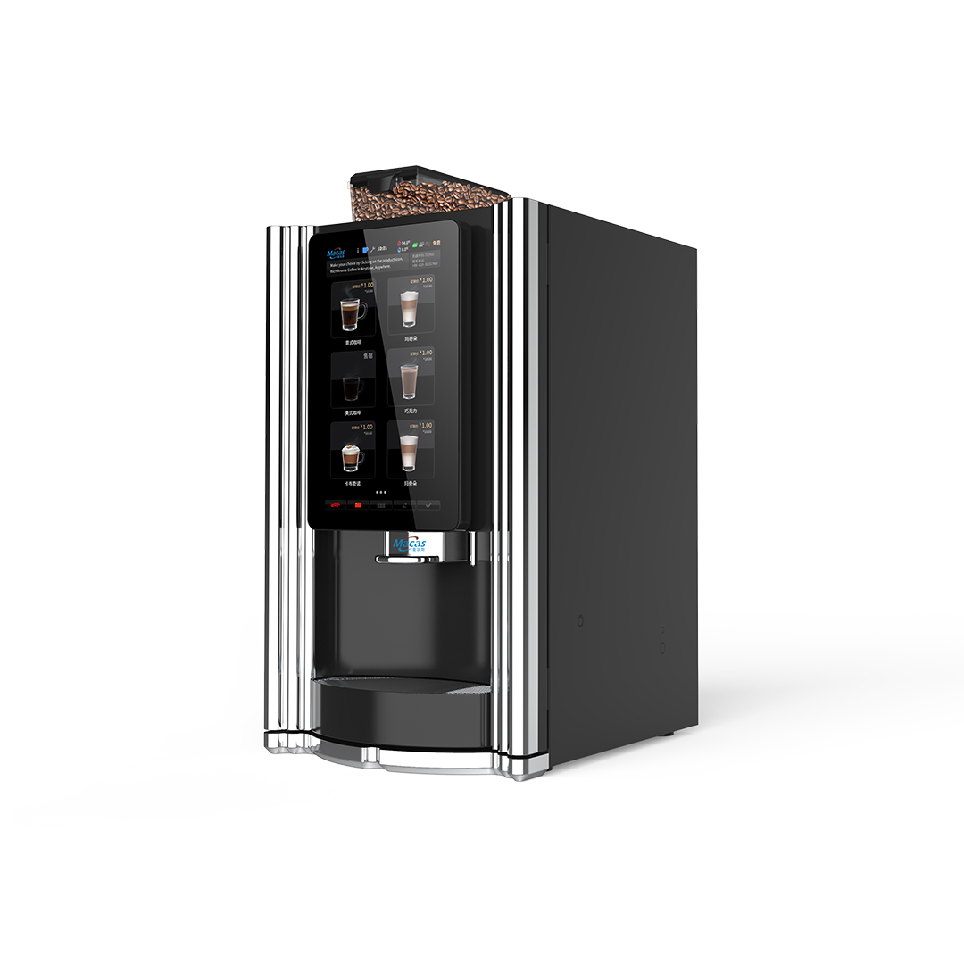

WIFI signal strengthening antenna

Drink outlet

Coffee bean bin (capacity 1.5 liters)

15.6-inch display

Drip tray (capacity 1.2 liters)

## 2.5 View of the product's internal structure

WIFI antenna

Instantproduct containers

Coffeebeanbox

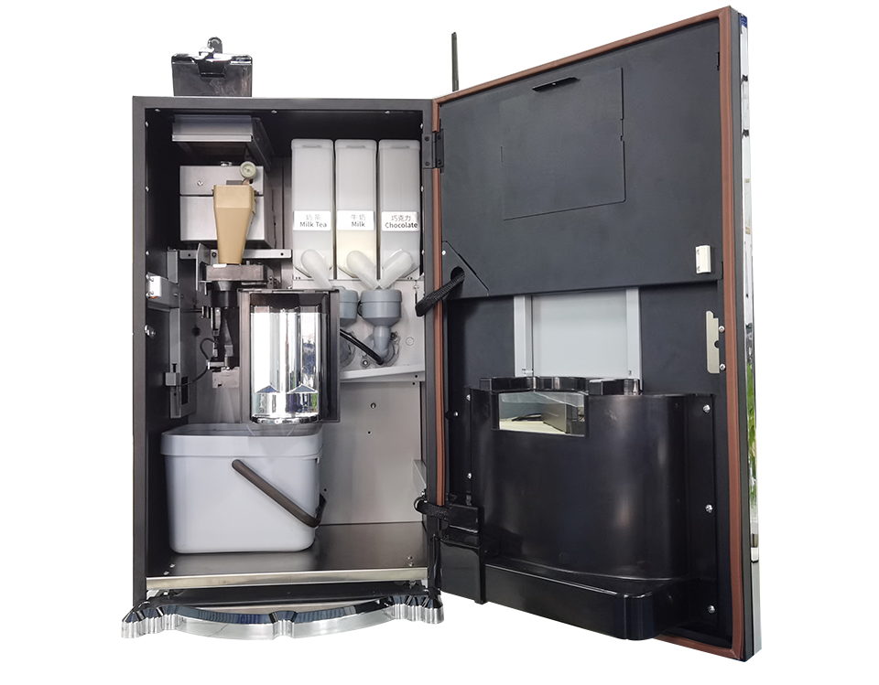

Door magnetic sensors

Grinder

Door magnetic sensors

Mixer

Coffee Brewer

Product drink spout

Coffee waste bin

Drip tray

## 2.6 View of the hardware architecture and wiring on the back of the product

Steamextractionfan

Stream extraction fan

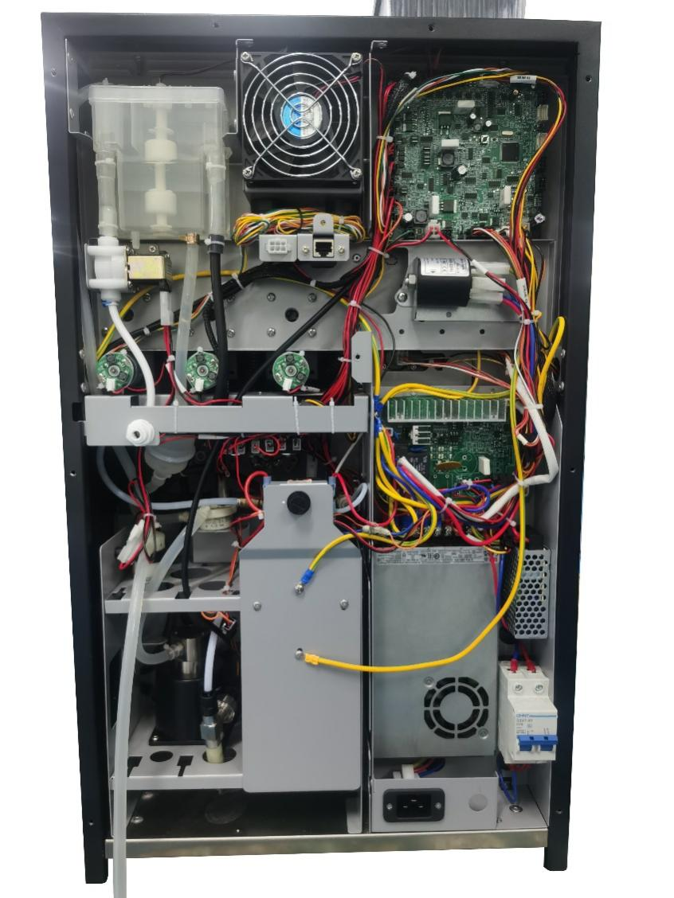

MDB

Gear pump

12V power supply

24V power supply

220V power input connector

220Vor 110V Strong electrical panels

**IO** boards

Earth leakage protection switch

Boiler water circuit

flowmeter

Three-row vavle

Tap water outlet

RJ45 interface

Material box motor

Watertank

## 2.7 User Interface

The EVOCA automatic freshly ground coffee machine is a new generation of coffee machines mastered by a 15.6" touch screen, which offers an intuitive user page, comprising a consumer page and an operational page.

The consumer page (hereinafter referred to as the CUI), similar to the mobile phone operation page, is shown in the following figure.

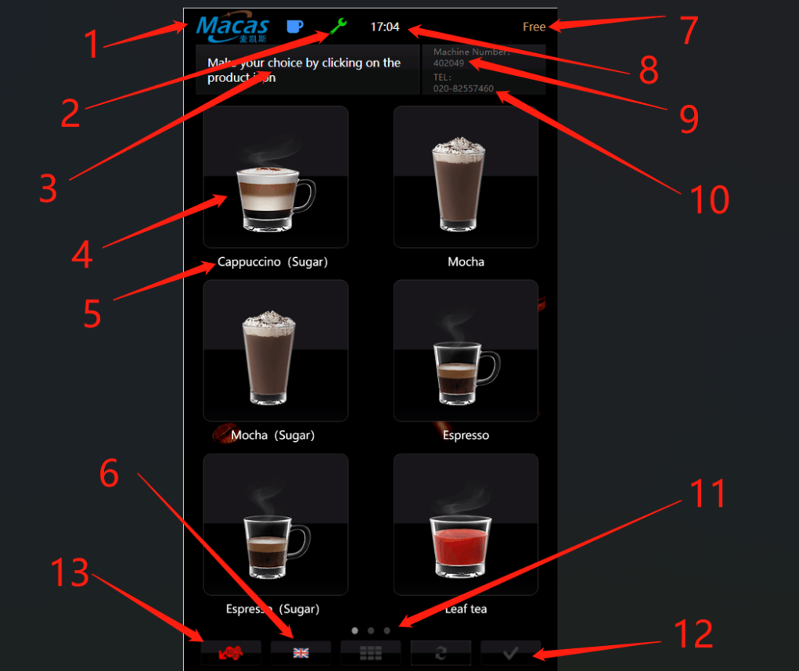

Notes.:

1.Company name or logo;

2.Backstage button: Enter "2020" to access the machine's backstage page, enter "1010" to enter the recipe editing page;

3.Reminder message;

4.Product images;

5.Product name;

6.Language switch;

7.Automatic vending mode: Display as "Free" or current balance;

8.Current time;

9.Machine number;

10.After-sales hotline;

11.Next page;

12.Confirm button;

13. Cancel/Refund button.

## 2.8 Machine configuration

The configuration of this model can be customised to meet customer requirements, to order it please contact EVOCA pre-sales service.

### **2.8.1 Configuration layout (canbe adapted to customer requirements)**

|  |  |  |  |
| --- | --- | --- | --- |
| MACES4C-00 | | | |
| 2.2L | 2.5L | 2.5L | 2.5L |
| Coffee  beans | Milk tea powder | Powder milk | Chocolate |

## 2.9 Machine water circuit schematic (for reference only)

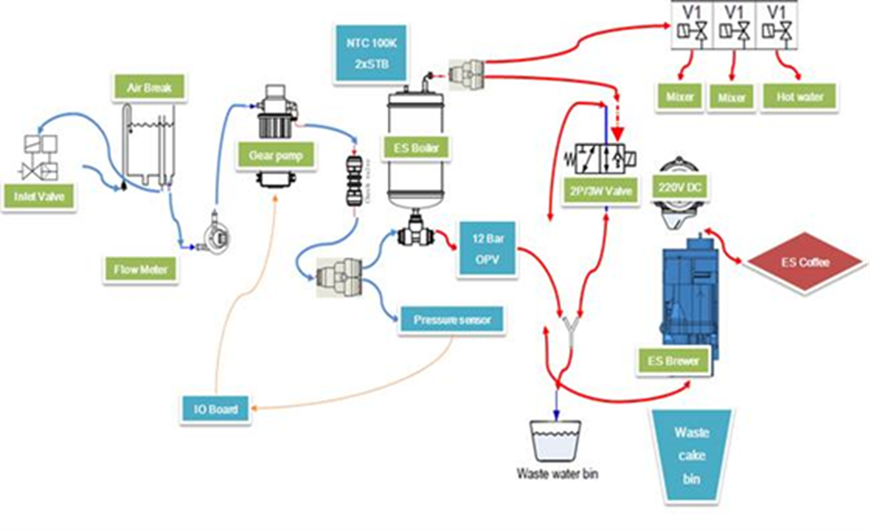

|  |
| --- |
| **attention:** |
| The machine configuration has been updated and iterated, and the schematic diagram of the machine waterway is for reference only! |

# 3 Transport and storage

## 3.1 Shipping Transport

This machine is packed in a wooden box or carton to prevent damage, humidity and dust.

or any claim, the goods must be inspected immediately for damage or loss and photographed for evidence, and the consignee must sign the receipt.

|  |
| --- |
| Attention**:** |
| Risk of shipping damage!  1.To avoid damage;  2.Please transport the machine upright, do not transport the machine upside down;  3.Do not stack machines;  4.Do not place heavy objects larger than 10 kg on top of the machine;  5.Avoid tipping and dropping the machine during transportation. |

## 3.2 Transport and storage environment

|  |
| --- |
| **Note:** |
| To prevent damage tothe machine, pleasenote.  1.Use only at +5°C-+35°C. Cold and humid conditions can seriously damage the machine;  2.Ambient humidity range 10%-90%;  3.Store the machine in a dust-free and dry environment at a temperature range of 0°C-40°C. |

## 3.3 Machine shutdown

If the location changes or the machine is not used for a long period of time, the tank, pipes and boiler must be emptied of water. This prevents the tank from over flowing and the boiler from freezing and damaging the machine.

The machine software has a fully automatic emptying procedure, please refer to later chapters! (Refer to Emptying the boiler and Emptying the water tank).

|  |
| --- |
| **Beware:** |
| Risk of burns!  When unplugging pipes and joints watch out for hot water spurting out and scalding your body! |

# 4 Pre-operational preparation

## 4.1 Placement of machines

The machine is not suitable for and cannot be installed outdoors, but needs to be installed in a dry room at an ambient temperature of between 5°C and 35°C and not in a humid environment with air and water jets.

The machine will be positioned against a wall with a minimum back distance of 6 cm against the wall for effective fan ventilation, and the machine should be positioned with a maximum tilt angle of no

More than 2 degrees.

If required, adjust the feet appropriately to keep the machine as horizontal as possible.

## 4.2 Payment Systems

Mobile payments such as WeChat and Alipay for machines (please inform EVOCA pre-sales staff of the Alipay and WeChat interfaces for the corporate version before use.

## 4.3 Water source

If the machine is connected to a tap water source (filter must be used),please make sure that the water pressure is between 0.5Bar and 7Bar. Inside the machine, there is a small water tank to remove air from the tap water so as not to affect the accuracy of the boiler temperature control!

## 4.4 Product Formulation Setup

Please check with EVOCA for the first time on the type of drinks and recipe settings! EVOCA can make factory settings and test product recipes for new customers!

## 4.5 User definitions

User: the consumer, who selects the product according to the machine interface.

Service technician: familiar with the hazards of the machine and the technical mechanical equipment. And the ability to set up and maintain and repair.

The person who sets up the machines and is responsible for their correct installation and maintenance.

The person running the machine is responsible for the correct and regular replenishment and cleaning of the machine with raw materials.

# 5 Machine Installation

|  |
| --- |
| **Attention:** |
| Only personnel who have already been trained to install the machine should do so!  Please read the installation instructions completely and carefully!  Please confirm whether the machine is damaged before installation, some damage cases are more hidden!  If damage is found, please contact the shipping company to claim and take pictures for evidence, and notify EVOCA immediately to obtain after-sales |

|  |
| --- |
| **Attention:** |
| The way the machine is connected to the water source please confirm before installation, currently supports the built-in barrel water way!  The machine supports up to 1 standard 18.9 liter buckets of water! |

**For initial use there are the following steps.**

1.Placement of the machine at the place of operation;

2.Unpacking the machine (adjusting the machine's feet when it is found to be unstable or wobbly);

3.Opening the machine door with the key (checking for damage to the inside of the machine) ;

4.Connection of the machine to a water source;

5.Filled material boxes;

6.Placement of coffee waste bins;

7.Connecting the router and installing an external antenna;

8.Energizing;

9.The machine will automatically fill the water circuit system;

10.Making the necessary settings according to the client's needs.

|  |
| --- |
| **Remarks:** |
| Please pay attention to the neatness of the installation environment and dispose of the packaging materials in an environmentally friendly way! Packaging materials include, cardboard, film, foam, etc. |

## 5.1 Unpacking

Please check the machine for damage before installation, some of the damage is rather insidious!

|  |
| --- |
| Important: |
| Risk of failure!  Please refer to the following suggestions for:  1.The machine can be placed and run in a dry, well-ventilated room;  2.Usually placed on a flat, level surface;  3.The machine feet can be adjusted for horizontal placement.;  4.Ensure that there is sufficient space around the machine for maintenance and cleaning;  5.The distance between the backs must not be less than 6 cm (ventilation). |

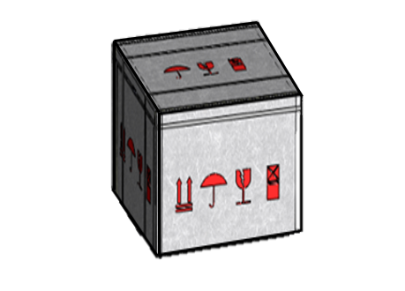

The machine is packed in cartons or wooden cases in some areas

## 5.2 Machine opening

|  |
| --- |
| **Caution:** |
| You can only open the door of the machine if you have the key and the code!  EVOCA is not responsible for damage caused by failure to operate the machine in accordance with the instructions! |

1.Five minutes after power on, the 15.6-inch screen lights up；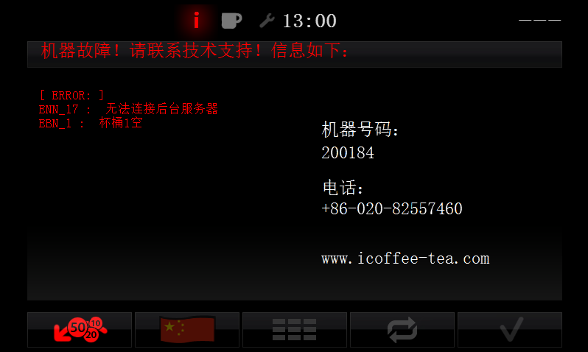

**This screen will appear after power on and power on**

2.Unlock the machine door with the key, open the door and check that there is no damage or missing parts inside the machine.

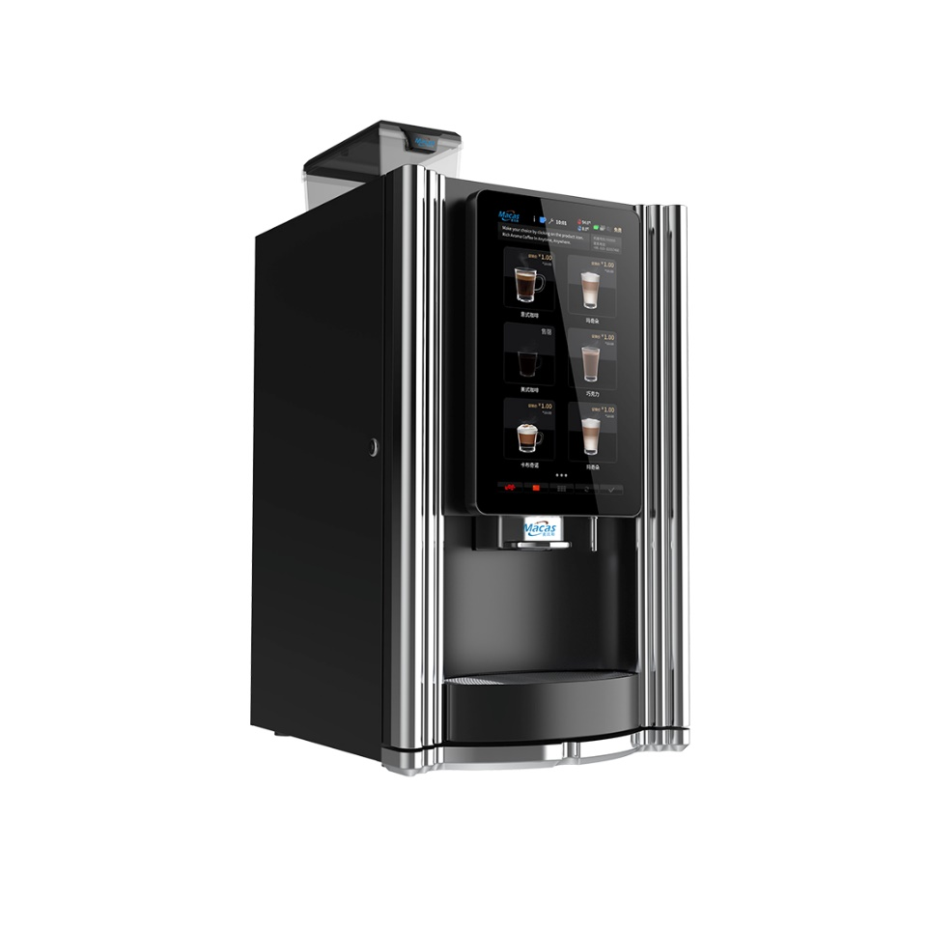

LOCK

### 5.2.1 Machine back office maintenance interface

After opening the machine door with a key, press the button and enter the password "2020" to access the machine's maintenance interface. If the machine cannot access the maintenance interface, please contact EVOCA Coffee's after-sales service!

**The maintenance interface includes the following buttons and areas:**

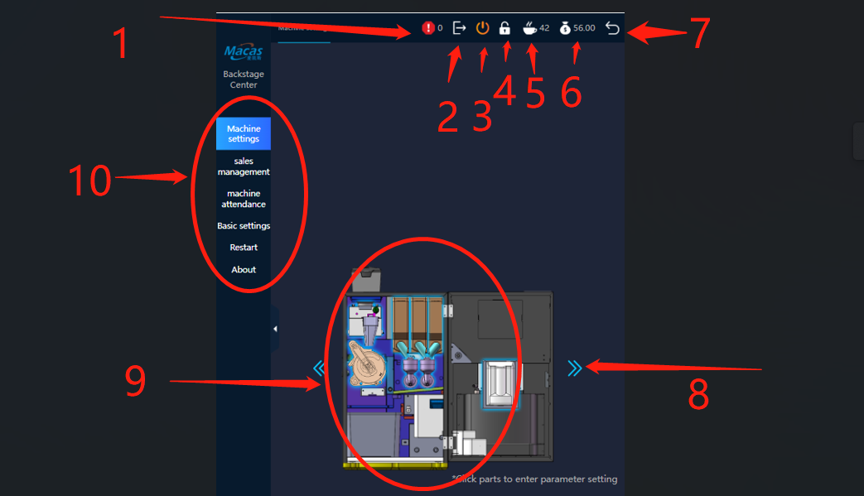

**Notes:**

1.Machine Fault Alert Button: By clicking this button, you can view any error messages displayed by the machine and clear the errors;

2.Exit Key Button: Pressing this button will take you to the Android back-end interface;

3.Power Off Button: Allows you to turn off the machine;

4.Authorization Password: The password is "2020" (usually no need to reauthorize after entering);

5.Cup Sales Record: Displays the recorded number of cups sold;

6.Machine Revenue Record: Shows the recorded amount of income generated by the machine;

7.Back Button: Returns to the sales interface when clicked;

8.Next Page: Moves to the next page;

9.Parameter Settings for Various Components: Clicking the corresponding icon allows you to enter the internal parameter adjustment settings for that component;

10.Function Button: Provides access to additional functions.

## 5.3 Connecting to a water sour

|  |
| --- |
| **Important!** |
| Please use clean and hygienic buckets of water!  1.Pay attention to the hygienic condition of the plumbing;  2.Clean the relevant parts;  3.Please connect the machine to a water source that is easy to operate;  4.Please note that the joints must be tightened to avoid leaks;  5.Please install the barrel dust cap (included with the machine inlet pipe). |

## 5.4 Filled instant powder canisters

Open the top cover of the canister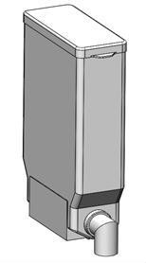.

**Material box cover**

|  |
| --- |
| Important**:** |
| Please do not press the powder by hand as it may be too tight and produce abnormal powder! |

|  |
| --- |
| **Note:** |
| When using the cartridge for the first time or after cleaning, note that the cartridge spout is empty, as this will result in a bland taste in the first drink.  The recommended filling volume for the material is more than one third of the cassette to ensure sufficient powder output. Before filling, make sure that the powder has not deteriorated or expired. |

## 5.5 Placement of waste bins and drip trays

|  |
| --- |
| **Note:** |
| Please note the position of the waste bin.  Ensure that the waste water full detection signal line is within the drip tray. |

## 5.6 Connecting the router,wifi and RJ45

|  |
| --- |
| **Attention:** |
| 1. To connect to the background server, the machine needs to plug in a network card to connect to the Internet;  2. The installation of the card must be carried out when the machine is powered off;  3. It is recommended to purchase the network access card from the official authorized business hall, which can ensure the stability and reliability of the network;  4. Note that the installation position and direction of the card are correct;  5. The network signal strength of China Unicom, China Telecom and mobile operators is affected by many factors. It is recommended to use the network signal of operators in the machine installation location which is relatively stable. |

**Install the network adapter**

1. The location of the router is as follows (as shown in Figure 1 below);

2. Press down the SIM card, and the card will pop out. Install the gap of the SIM card and insert the chip outward towards the lower left corner (position as shown in Figure 2 below);

3. Pay attention to the installation position of the network adapter (corresponding to the gap) as shown in Figure 3;

After inserting the card, enter the 2020 password to enter the background of the machine. Click the exit button to enter the background of Android. Click the Settings to close WIFI, open Ethernet and restart the machine.

RJ45 Network cable connection: There is a network port on the back of the machine. Plug in the network cable, turn off WIFI, turn on Ethernet, and restart the machine to connect.

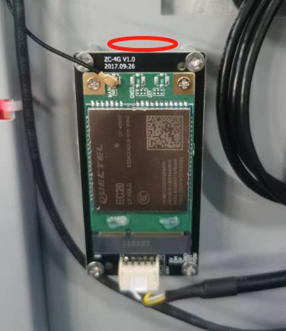WIFI connection: Turn off Ethernet, turn on WIFI, and enter WIFI password.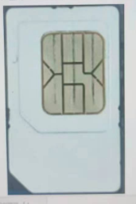

**Fig.3**

**Pay attention to the location of the network adapter when installing it**

**The SIM card socket is in this position**

**Fig.2**

**Take the cover plate and push it up to open the cover plate, router position**

**Fig.1**

## 5.7 Connect power and turn on

After completing the above steps correctly connect the machine's power cable to the socket, which should be placed in an easily accessible location. Ensure that the machine's earth leakage protection switch is on.

The first cold start of the machine takes about 5 minutes for the boiler to heat up!

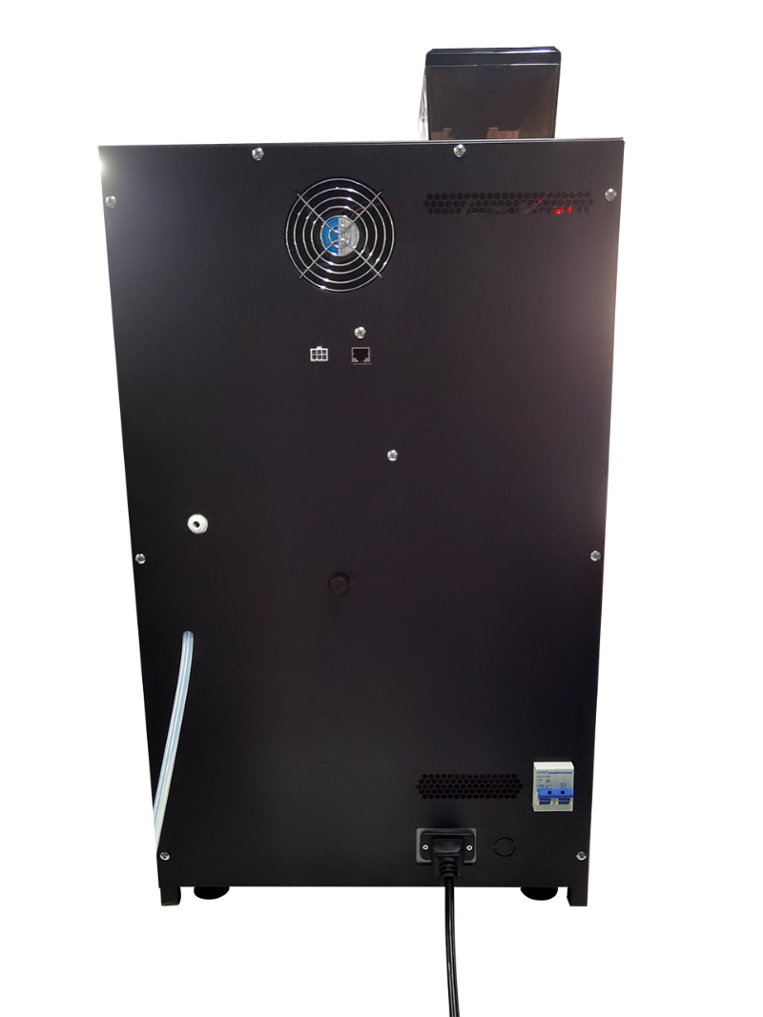

**power cord**

**220V input connector**

**leakage circuit breaker**

**Barrel water inlet pipe**

**Direct drinking water intake pipe**

**RJ45 network port**

**MDB interface**

|  |
| --- |
| Note: |
| Unsuitable voltage risks damage to the machine!  The voltage varies from country to country and region to region, please refer to the machine nameplate for details of the voltage used in the machine! Please take care to check the voltage, as there is a risk of damage to the machine due to voltage variations!  Please note the grounding condition of the place where the machine is placed! This is very important! |

## 5.8 Filling boilers

The boiler is automatically filled when the machine is switched on.

|  |
| --- |
| **Notes:** |
| When the boiler is filled the system will automatically heat up to the set temperature!  The hot water system has a temperature detection device that protects the machine by cutting off the power supply when the temperature gets too high with two thermal switches in the hot water system!  If this situation occurs, please contact EVOCA after-sales service promptly!  If the display shows that the boiler has failed to fill, switch off the machine for 2 minutes and  then switch it on again! If the boiler does not fill after three repetitions, please contact EVOCA |

## 5.9 Commissioning machines

There are several steps for commissioning the machine:

1.Calibration grinder;

2.Calibrate the accuracy of instant cartridge powder discharge;

3.Set up machine operation mode;

4.Beverage recipe setting;

5.Beverage price setting;

6.Automatic machine cleaning settings.

### 5.9.1 Calibrated grinder

|  |
| --- |
| Note: |
| Before adjusting the grinder, please prepare the (low value) electronic scale!  Please prepare fresh coffee beans before calibrating the grinder! |

In order to ensure the accuracy value is reliable, it is recommended to use the following similar electronic scales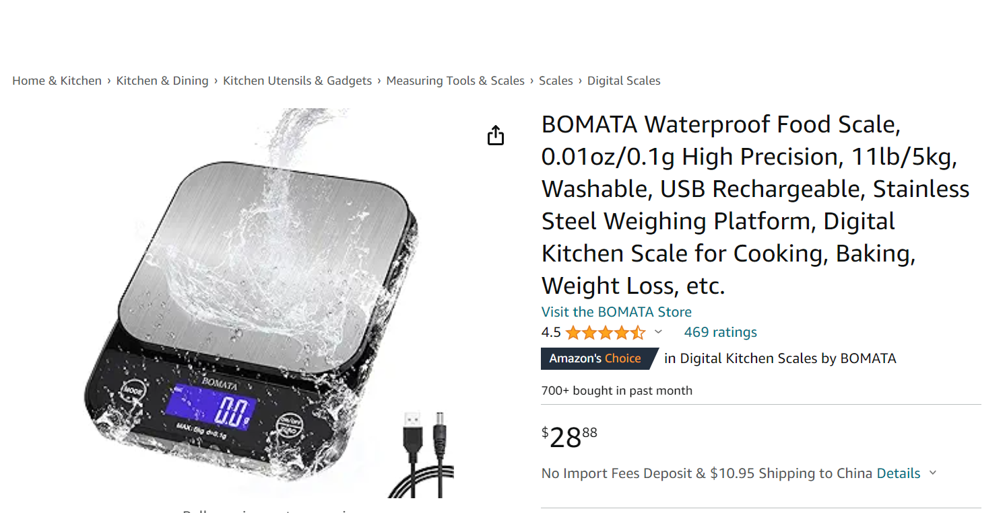

|  |
| --- |
| Brief description of the role of the grinder. |
| Grinding the coffee beans to produce a uniform coarse and fine coffee powder. |

|  |
| --- |
| A brief description of the thickness of coffee powder: |
| Generally speaking, the coarser the ground (coffee powder), the shorter the extraction time, the finer the ground (coffee powder), the longer the extraction time, the grinding thickness of coffee beans will also affect the taste, under the premise of consistent objective conditions, generally speaking, the finer the ground, the more obvious the bitter taste of coffee, relatively will cover up other rich taste of coffee, the coarser the ground, the heavier the sour taste. Too much acidity can make coffee difficult to taste, so you can also fine-tune the grinder to bring out some of the coffee's unique flavor. However, this adjustment should be a moderate fine-tuning based on the grinding degree corresponding to the appliance. |

**Calibration of the grinder process:**

Step 1: 

Click on the button shown in the image and enter the password "2020" to access the machine's maintenance;

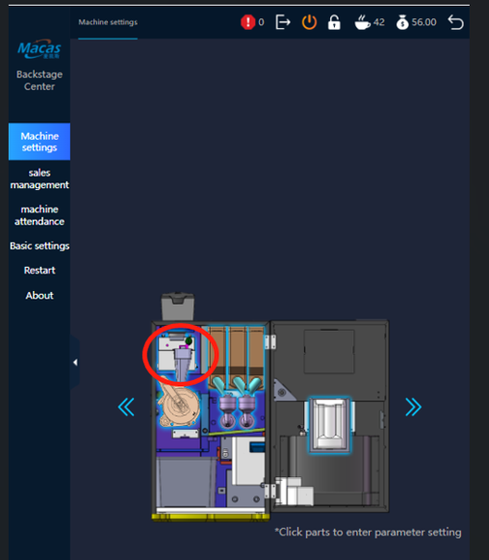

Step2.

Gently pull out the powder outlet of the grinder (grasp the outlet and pull it out gently;

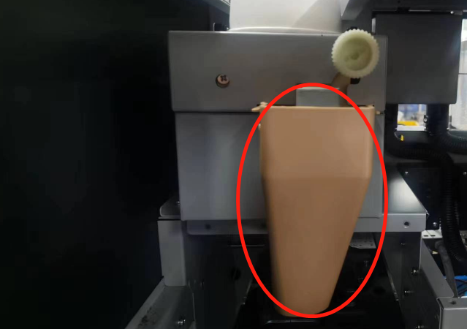

Step3.

Click on ‘Test’ then Calibration,

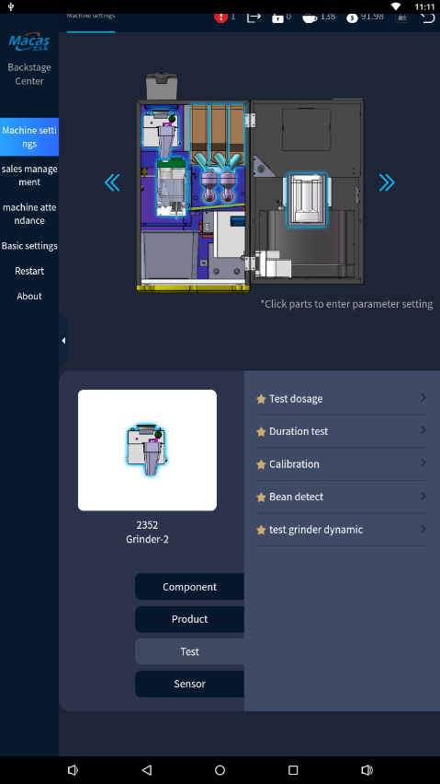

And then we go to this screen;

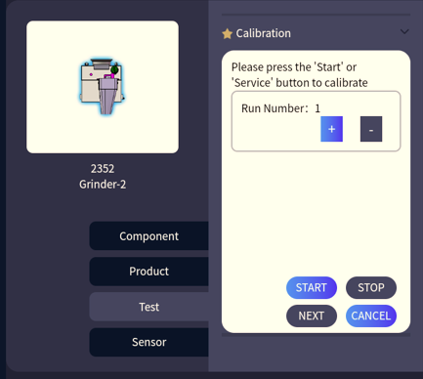

Step four.

How to use the grinder coarse and fine regulator;

|  |
| --- |
| Use of the grinder coarseness regulator. |
| The grinding fineness can be adjusted by rotating the grinding fineness adjustment knob. Clockwise rotation will result in finer coffee grounds, while counterclockwise rotation will make the coffee grounds coarser.  If the coffee flow is too slow (intermittent flow), it indicates that the coffee grounds are too fine. In this case, you need to rotate the grinding fineness adjustment knob counterclockwise to make the coffee grounds coarser. If the coffee flow is too fast, it means that the coffee grounds are too coarse. In this case, you need to rotate the grinding fineness adjustment knob clockwise to make the coffee grounds finer.  Adjust the grinding fineness adjustment knob based on the flow speed of the Italian espresso coffee product. |

Grinder coarseness adjuster position;

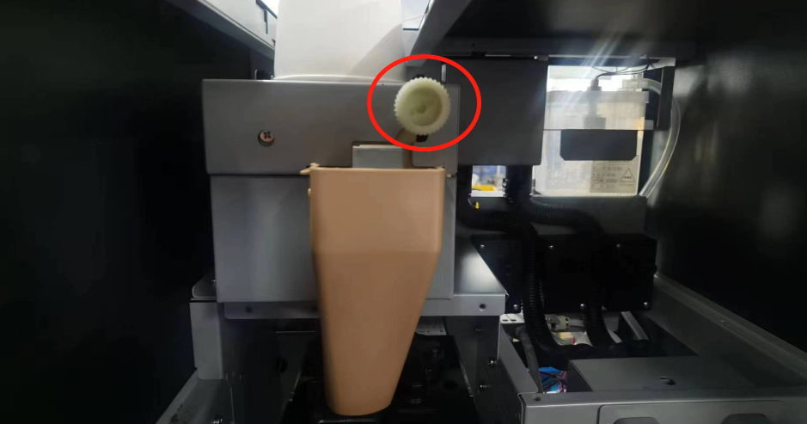

Step 5.

Take a clean paper cup and tare it on the electronic scale (note that the unit value is set to g g)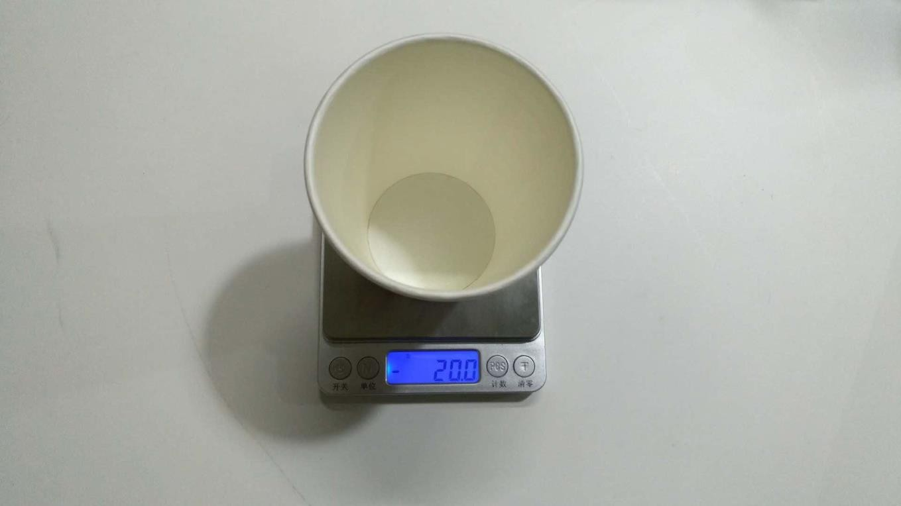;

Step 6: Grinder calibratio n:

1.Click on the "Start Calibration" button (Note: After clicking the "Start" button, immediately hold a cup to catch the coffee grounds being ground by the grinder);



2.Place the cup here to collect powder;

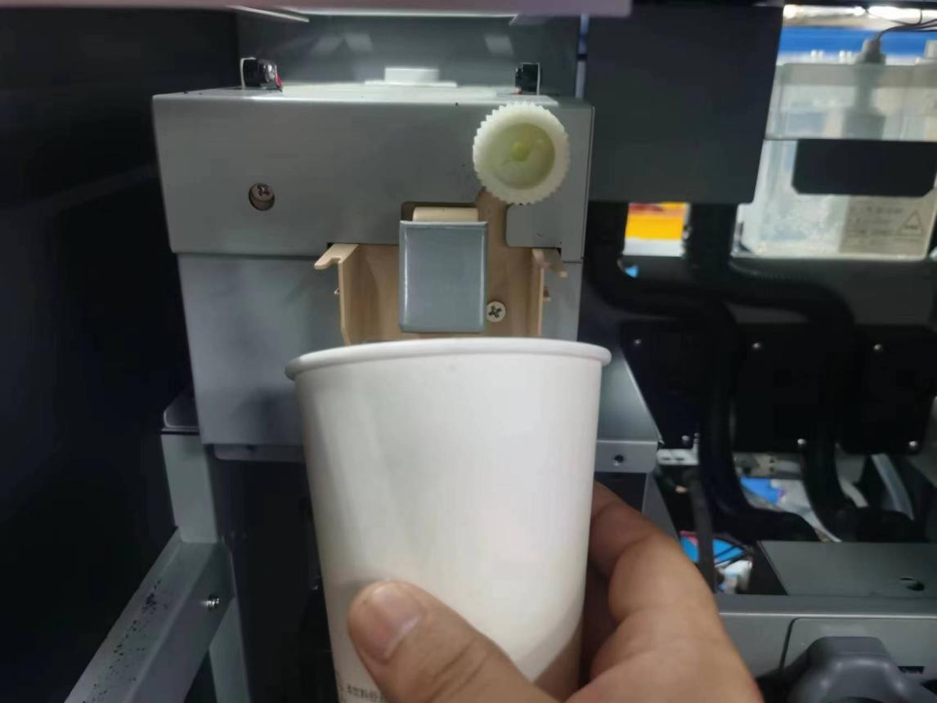

3.The ground coffee powder is weighed on the electronic scale and the value is entered in the calibration screen;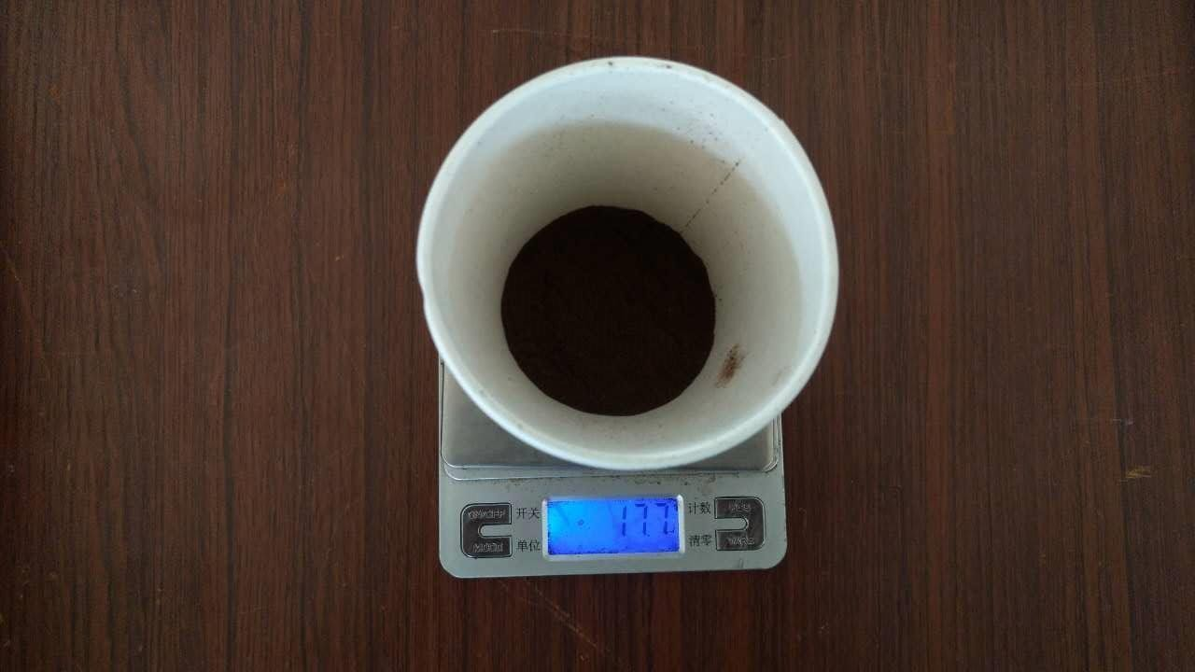

4.Enter the weight of the coffee powder and click "ok" to save the data;

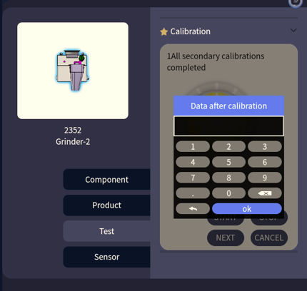

|  |
| --- |
| **Importance：** |
| It is recommended to calibrate three times and observe whether there is a large error in the actual calibration value (the error is within plus or minus 3 grams).  Calibration is not allowed to cause abnormal powder machine!  The weight of the cup must be reset and ignored during calibration.  Freshly unpacked coffee beans must be used for calibration. |

### 

### 5.9.2 Calibrated instant cartridges

Cassette calibration is software made for the physical properties of instant cassettes and the physical properties of powders. Before the calibration you need to prepare the electronic scale and the cups.

|  |
| --- |
| Important**:** |
| Inaccurate calibration will cause the machine to produce abnormal powder!  It is recommended to calibrate three times and observe whether there is a large error in the actual calibration value (error within plus or minus 3 grams.  The weight of the cup during calibration must be zeroed out and ignored. |

|  |
| --- |
| Attention: |
| Freshly unpacked powder must be used for calibration.  When the machine changes cassettes, motors and powder types, it needs to be re-calibrated every time, because each part or powder has different physical properties!  The powder in the cassette must be greater than 1/3 of the volume of the cassette when calibrating |

Step 1.

Go to the machine background maintenance;

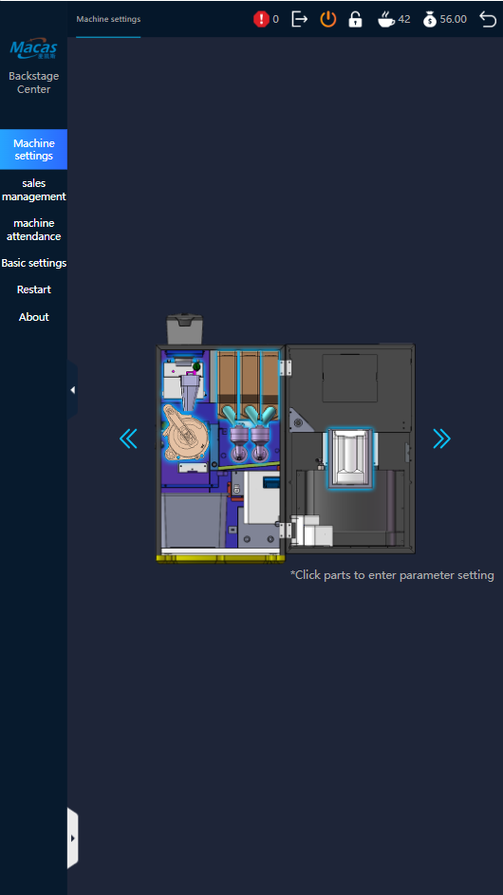

Step 2.

Select the cartridge to be calibrated and click on the parameter screen;



Step3.

Click on the "Calibration l" icon in the test bar and click on start, then take the cup and catch the corresponding cassette spout to catch the powder, note (the cup must be weighed and tared before catching the powder);

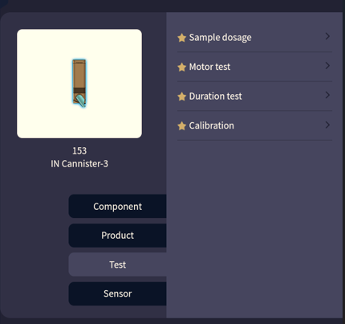

1.Please remove the stirrer under the cassette outlet, prepare the cup and the electronic scale, weigh and zero it;

2.Place the cup under the spout of the cassette;

3.Click on the "Start" icon, the machine will automatically dispense the powder three times and catch the powder in a cup.

Catch the powder in the cup.

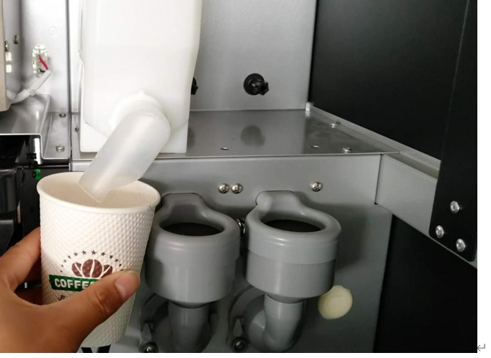

Step 4.

Just weigh the powder on an electronic scale and enter the weight value.

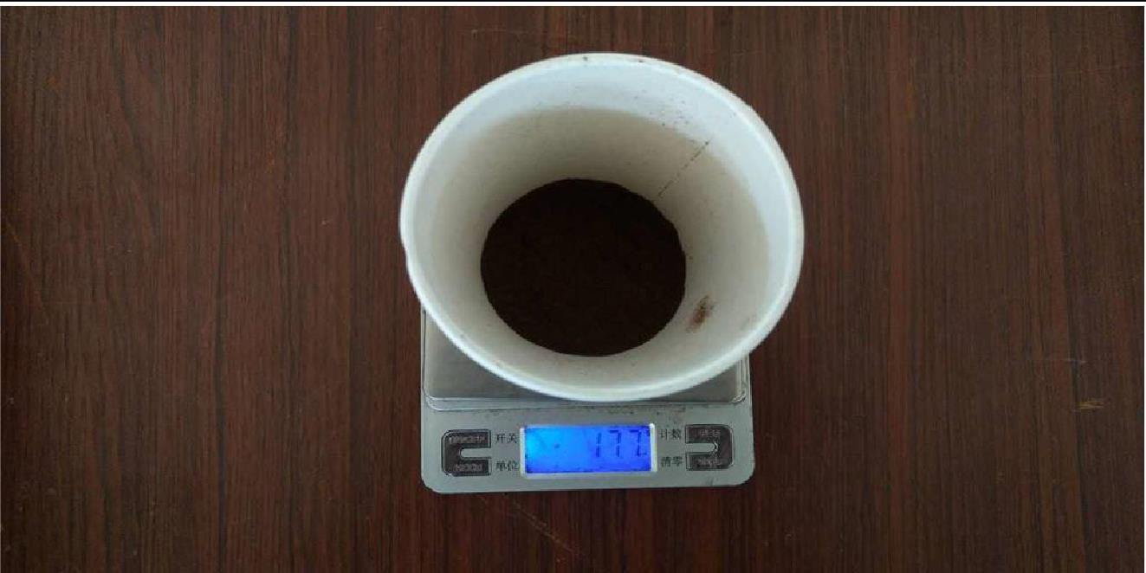

|  |
| --- |
| **Importance：** |
| It is recommended to calibrate three times and observe whether there is a large error in the actual calibration value (the error is within plus or minus 3 grams).  Calibration is not allowed to cause abnormal powder machine!  The weight of the cup must be reset and ignored during calibration.  Freshly unpacked powder must be used for calibration. |

## 

## 5.10 Setting the machine's vending mode

1.Enter the machine background maintenance interface;

2.Click Basic Settings, click Options, click cconfig click Transaction; 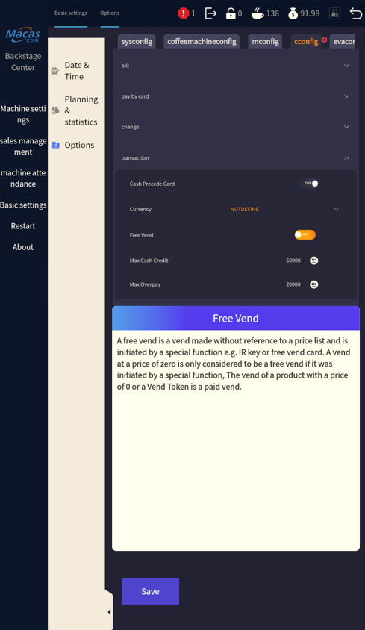

3.Click "Transaction" button, "ON" and "OFF" appear in free mode, ON stands for free mode, and OFF stands for charging mode. After setting, click save below to save；

4.After setting, restart the machine to take effect;

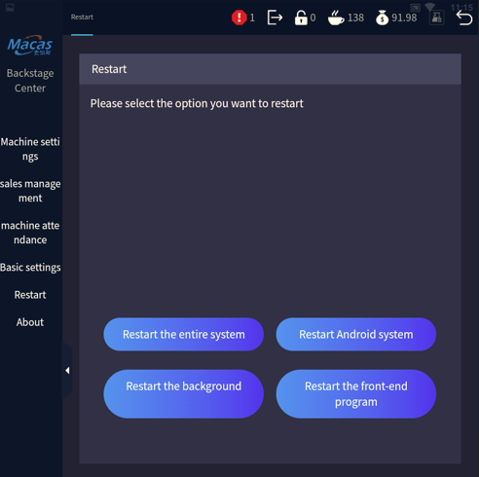

5.Click the "Back" button in the upper right corner of the interface to return to the sales interface. Check that the word "free" will no longer be displayed in the upper right corner of the touch screenof the machine and the amount of the sales price will appear above the product.

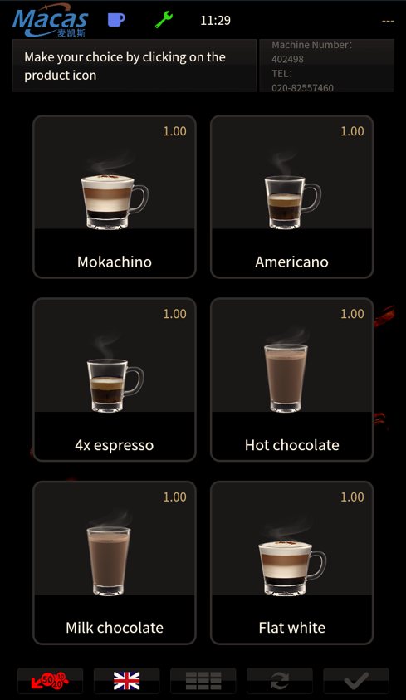

## 5.11 Beverage recipe setting

|  |
| --- |
| Note: |
| Please contact EVOCA pre-sales service to confirm the drink recipe before the machine is shipped. Recipe changes require a highly trained professional to handle. |

1.Open the door ,click on,and enter the password (factory default 1010) to access the background maintenance interface;

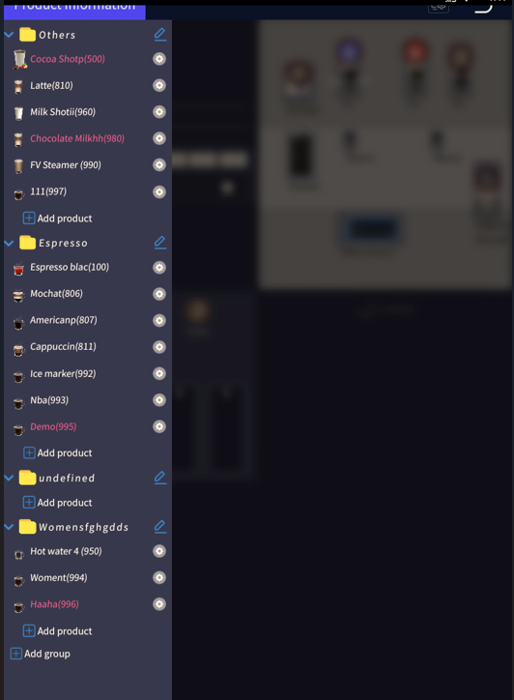

2.Click on the product that needs to be adjusted accordingly;



3.Click on the powder or water amount to be adjusted;

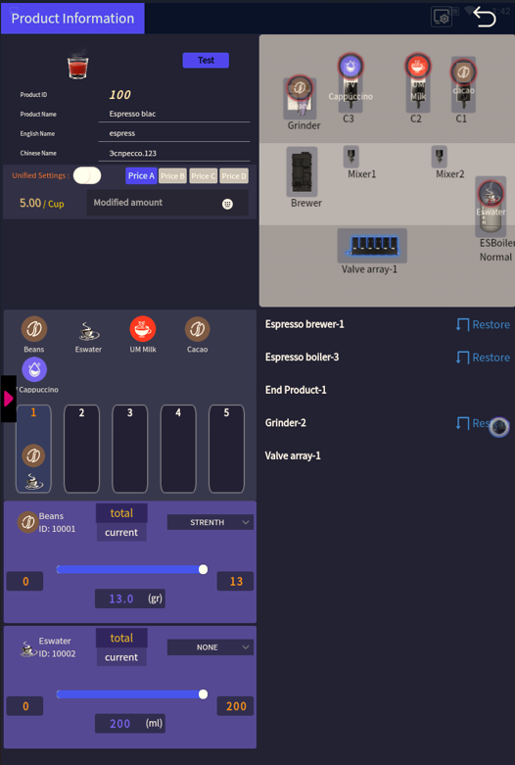

4.If necessary, click on "Test" to confirm that the taste is suitable;



5.After adjusting the recipe, the software needs to be restarted to save the adjusted data, and the machine can be started again after the restart.

## 5.12 Beverage price setting

 **set interface:**

10

12

11

9

822

7

6

5

4

3

2

1

Note:

1. Current products;

2. Product ID;

3. Product name;

4. Product display name;

5. Product price setting;

6. Raw materials that can be put into the machine;

7. Sequence of product discharging steps;

8. Coffee and milk concentration adjustment switch;

9. Adjust the amount of powder and water for discharging;

10. Test and make the product;

11. Layout of raw materials for the machine;

12. Advanced Settings (for the advanced parameters of product adjustment, please contact the after-sales staff of Aiweka for adjustment after training).

### 5.12.1 Beverage selling price setting

1.Open the door, click on  and enter the password (factory default 1010);

2.Click on the Product you want to change;



3.Once you have set the prices for A, B, C, and D, click on the "Save" button to save the changes. The A price represents the regular selling price of the machine, while the B, C, and D prices are for promotional prices during specific time periods. Make sure to enter the corresponding prices for all the categories to complete the setup.

### 5.12.2 Different prices for different time periods

1.Click on,and enter password 1010. you have set the prices for A, B, C, and D, click on the "Save" button to save the changes. The A price represents the regular selling price of the machine, while the B, C, and D prices are for promotional prices;

2.Click on“,and enter 2020.

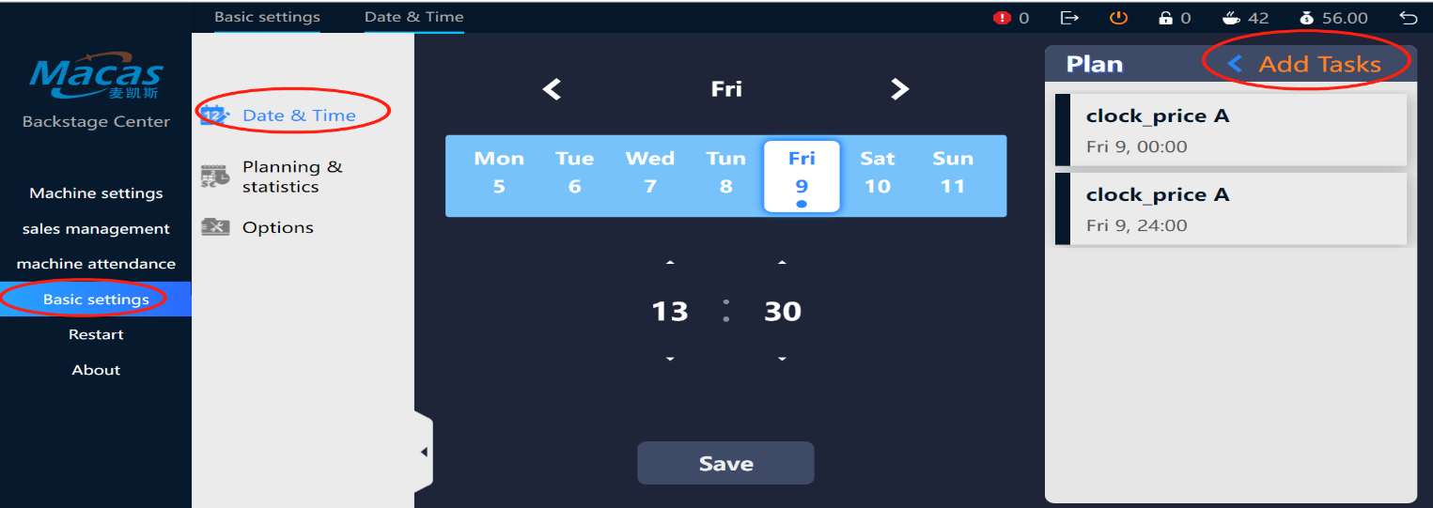

## 5.13 Automatic machine cleaning settings

|  |
| --- |
| Notes. |
| The automatic cleaning of the machine can effectively avoid the clogging of the mixer, brewer and pipes. And keep the inside of the machine in good hygienic condition! |

1.Open the door，click onand enter 2020;

2.After setting the fixed flushing time, click on the "Save" button;

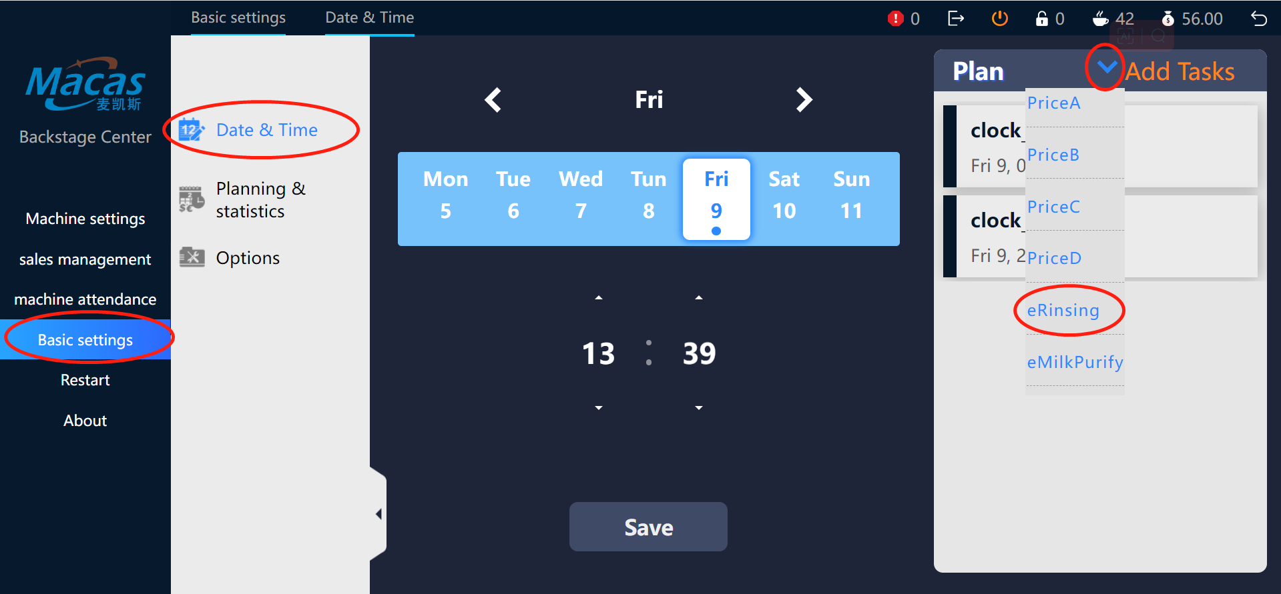

3.Please refer to the following image for manual flushing instructions;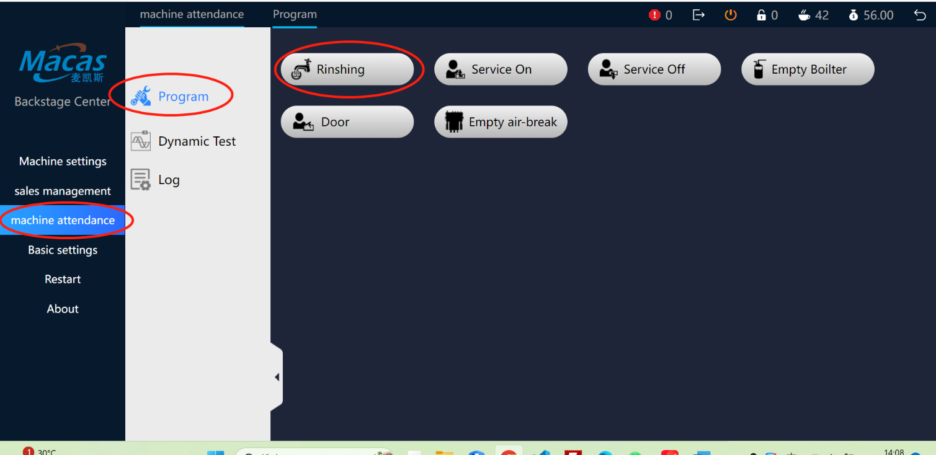

# 6 Turnover & Accounts

Click on "Reports & Financials (Sales List") in the upper right corner of the back office maintenance screen.

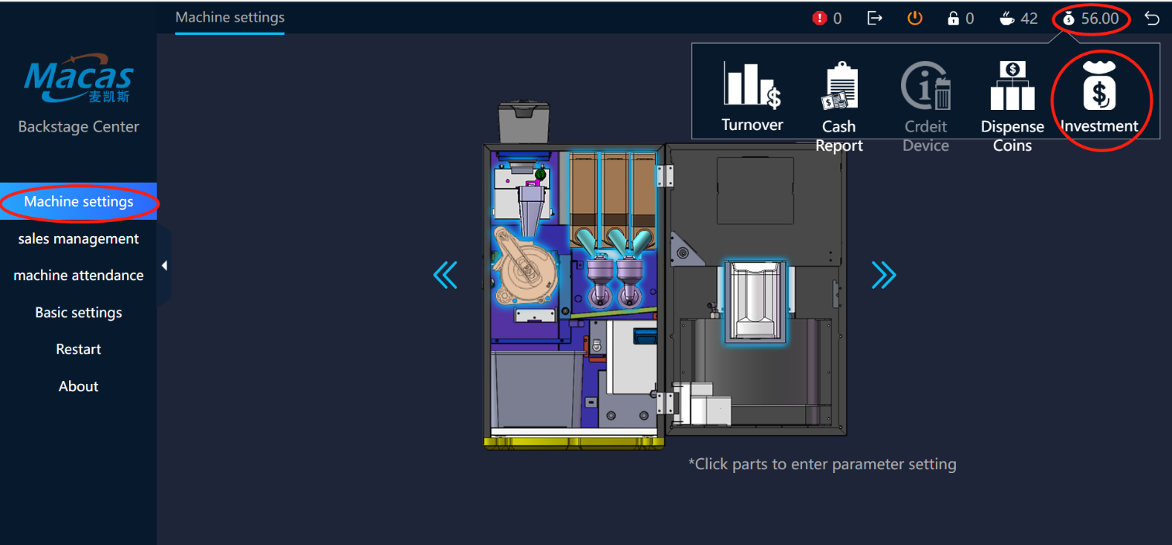

l

|  |
| --- |
| **Illustrate ：** |
| The accumulated/recent data comes from the international EVA general standard protocol: initialization/restore to factory settings. The "cumulative" setting means that the sales data cannot be reset and the statistics will start from the effective use of the machine. "Recent" will be cleared every time EVA PDA or remote data collects data.  Click on the header of each column to sort the table. |

# 7 Machine function options

The machine buttons show the various parts of the machine.

lick onand enter 2020,Lick on‘machine settings ’you would see the parts inside.

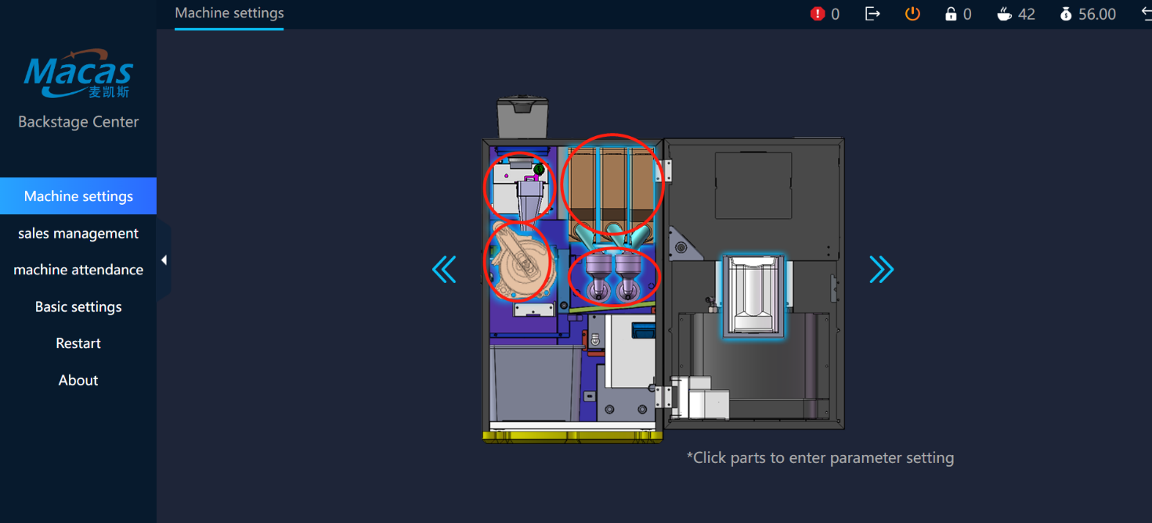

Adjustments

Note: The machine is set by factory default. Please check the meaning of each parameter before changing it.

|  |  |  |
| --- | --- | --- |
| Part Type | Adjusted for | Remarks |
| Cannister | Speed | Set a fixed speed for powder volume testing  Default:60 |
| Waiting time | Waiting time for testing powder volume  Default:0.5 |
| Buffer time | Buffer time for motor operation  Default:8 seconds |
|  | Amount of powder | Grams of powder for testing powder quantity  Default:5g |

|  |  |  |
| --- | --- | --- |
| Mixer | Waiting time | Waiting time for instant ingredients.  Default:0 seconds |
| Rotational speed | Motor speed  Default:80 |
| Closing time | Mixer motor runs for a few seconds and then the pump stops |
| Espresso boilers | Gear pump speed | Gear pump speed |
| Boiler temperature setting | Boiler temperature |
| First cup boiler rise temperature | How much the boiler temperature rises to produce the first drink |
| Grinder | Test powder volume | Total amount of test powder |
| Valve sets | Closure delay | Valve closing delay time |
| Cup dispenser | Cup dispenser motor speed | Cup dispenser motor speed.  Default:40 |
| Roller motor speed | Roller motor speed  Default:25 |
| Cup holder | Receiving speed | Cup motor speed  Default:30 |

Testing

|  |  |  |  |
| --- | --- | --- | --- |
| Part Type | | Testing | Rema rks |
|  | Cannister | Test sample powder volume | Set the amount of powder in the "Dose" dispenser |
| Motor testing | Let the motor run for a few seconds |
| Powder volume test | Set a fixed speed for the amount of powder in the "Speed" section |
| Calibration | Calibrating the cartridge |
| Test sample powder volume | Set the amount of powder in the "Dose" dispenser |
|  | Mixers | Stirrer test | Run the mixer for a few seconds |
| Connection test | Test the mixer motor for proper connection |
| Espresso Brewers | | Brewer test | . Testing the operation of an espresso brewer |
| Brewer powder volume | The espresso brewer turns to the powder catching position |
| Brewer pressure | Espresso brewer turns to press position |
| Squeeze | Espresso brewer turns to squeeze position |
| Clean brewers | Testing the operation of a clean brewer |
| Pressing plunger down | Pressing plunger down |
| Espresso  Boilers | | Gear pump speed | Gear pump speed |
| Setting of boiler temperature | Boiler temperature |
| Boiler first cup temperature | How much the boiler temperature rises to make the |
| control | first drink |
| Grinder | | Dose testing | Dose testing |
| Calibration | Perform calibration |
| Out of the mouth | | Spout back to default position | Spout back to default position |
| Spout turned to test position | Spout turned to test position |
| The spout is transferred to the position of other products | The spout is transferred to the position of other products |  |
| Valve sets | | Test valves | Test for proper valve connection |
| Cup dispenser | | Test cups | Testing of cup dispenser components |
| Stirring rod dispenser | | Drop the stirring rod | Stirring rod dispenser drops stirring rod as instructed |
| Air pumps | | Testing air pumps | Start the air pump to test |

# 8 Consumer use of the machine

|  |
| --- |
| Note: |
| Please place the cup in the right  place before making the product! Please choose the right size cup!  Please consider the choice of cups with some anti-scald function for a better consumer experience! |

**How to get a drink from the machine**

1.The user interface is as follows;

2.Choice of a beverage;

3.Placement of cups of suitable capacity;

4.Adjust the taste in the touch screen with five levels and then confirm; (this step can be cancelled in the factory settings according to the customer's needs, please contact EVOCA after-sales service if you have special needs);

5.The machine will appear with the payment method (WeChat QR code, Alipay QR code).;

6.The machine automatically starts making the drink after the code has been successfully scanned

A prompt on the touch screen interface, together with an audible alert, when the drink has been made. 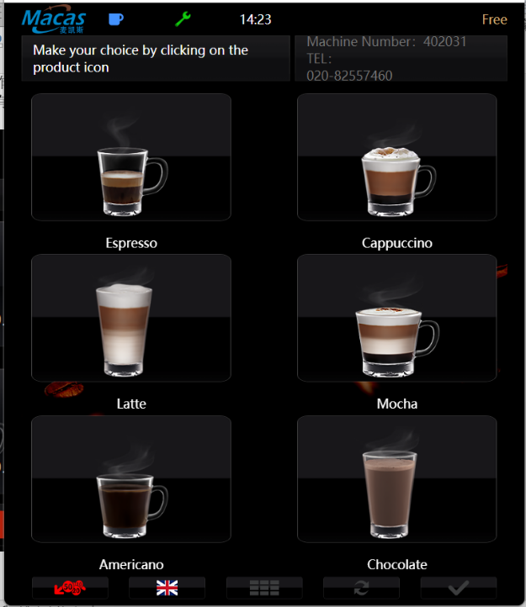

1.Taste adjustment in the touch screen with a choice of five levels;

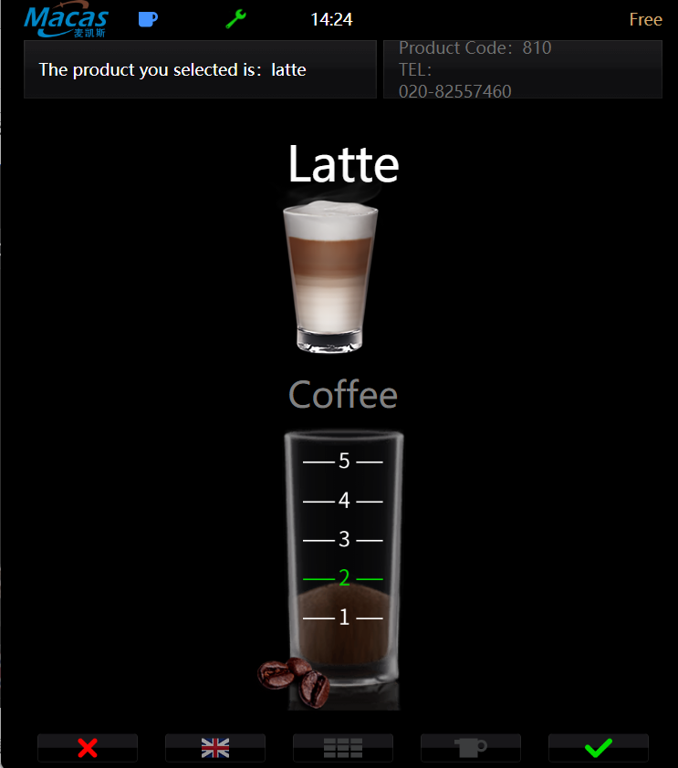

2.Prompt text and audio notifications are displayed on the touchscreen interface after beverage preparation;

3.Customers can customize the user interface language according to their preferences.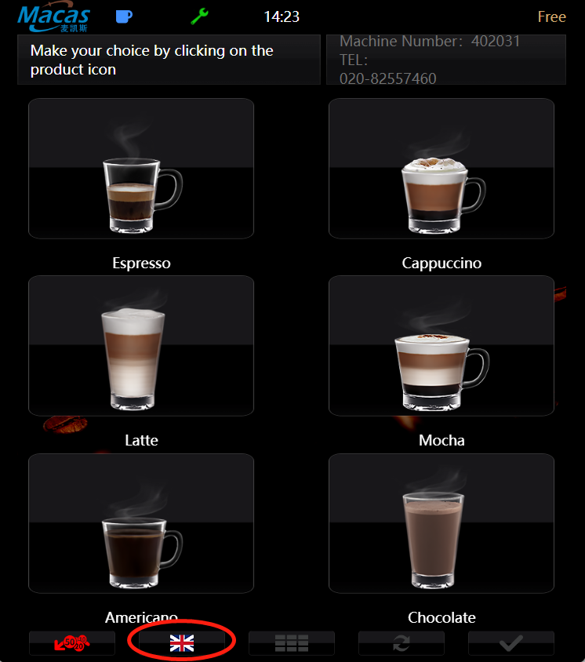

# 9 Cleaning and maintenance

Completely cleaning and maintenance of the machines is a fundamental requirement for achieving a very hygienic beverage service. Only if the machines are regularly and carefully maintained, cleaned and serviced can they deliver superior tasting drinks and ultimate customer satisfaction.

Always remember: only a good machine can work perfectly!

When designing these machines, EVOCA took into account all the important criteria to achieve lower maintenance costs and higher operational efficiency.

|  |
| --- |
| Note**:** |
| If the cleaning temperature is too high, they can damage the plastic parts! High washing temperatures can cause damage when cleaning plastic machine parts in the dishwasher!  Washing temperature must not exceed 65°!  Aluminium parts should not be washed in the dishwasher! |



## 9.1 Safety regulations for cleaning and washing

Before starting any work, please note the following safety instructions!

|  |
| --- |
| **Danger！** |
| Danger of electricity leakage!  Before making any repairs, turn off the machine, then unplug it, and do the repairs! |

|  |
| --- |
| **Caution:** |
| Cleaning and maintenance work not assigned to the customer can only be performed by a trained person, a person who has set up the machine or a technician who is familiar with the dangers that can occur when turning on the machine! |

|  |
| --- |
| **Caution!** |
| Be aware of the risk of injury from high water pressure!  When cleaning and maintaining a boiler or pipe, proceed in the following order:  1. Cut off the drinking water supply.  2. Unplug the pipe before performing necessary maintenance operations. |

|  |
| --- |
| **Caution!** |
| Burns are dangerous!  There are hot parts inside the machine. |

|  |
| --- |
| **Caution!** |
| The danger of moving parts clamping hands!  The brewing unit has parts that move on their own without power outages. Don't put your hands on the moving parts. |

|  |
| --- |
| **Attention:** |
| Danger of damage!  Machine cannot be flushed with water or pressure washer! Short circuits can cause internal machine parts to get damaged!  Inadequate cleaning and maintenance may cause the machine to wear out or break down too quickly. |

## 9.2 Cleaning

Clean carefully and regularly as recommended and maintain. Please refer to 9.6 Cleaning solutions!

## 9.3 Spoiled food

|  |
| --- |
| **Caution!** |
| * Eating spoiled food can make you sick! * The food sold is prone to spoilage. * Therefore, the following recommendations must be considered. * Consider the shelf life date on the product packaging. * Preferably, the product that is not used with the product that has nearly reached its shelf life. * Products for machine use only. * Use only the cleaning solution recommended in the cleaning program and pay attention to the instructions on the package. |

## 9.4 Cleaning Solutions

|  |
| --- |
| **Attention:** |
| A clean solution that does not fit can put you at risk of injury!  Use our approved and recommended food environment only when we are cleaning the machine! Cleaning the product irregularly may result in unnecessary wear and tear or electrical damage. Manufacturer's usage and safety recommendations must be followed! |

## 9.5 Basic cleaning work

|  |
| --- |
| **Attention:** |
| Cleaning work needs to be done according to the actual condition of the machine, if there are no special circumstances, please follow the cleaning and maintenance list strictly! For the cleaning and maintenance list, please refer to the attachment! |

# 9.6 Cleaning and guidelines

### 9.6.1 Opening and closing doors

You can only open the door of the machine if you have the key!

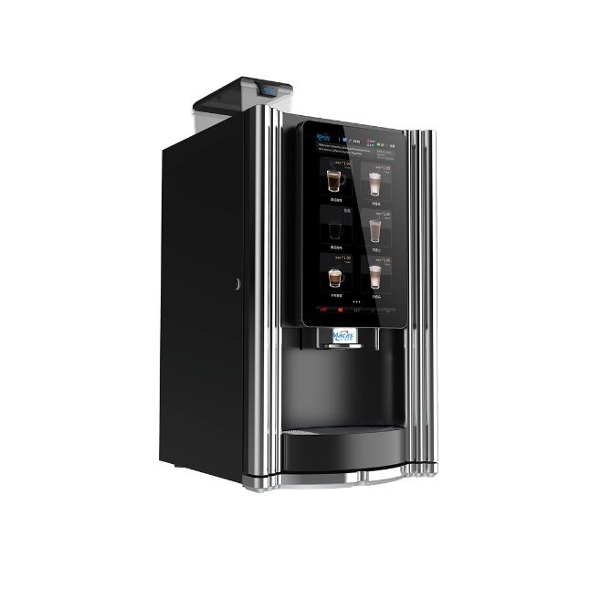

Lock

### 9.6.2 Cleaning instant material box

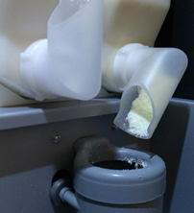This model machine has three cassettes, as follows.

**Please clean up the residue of the powder when it appears in the powder outlet.**

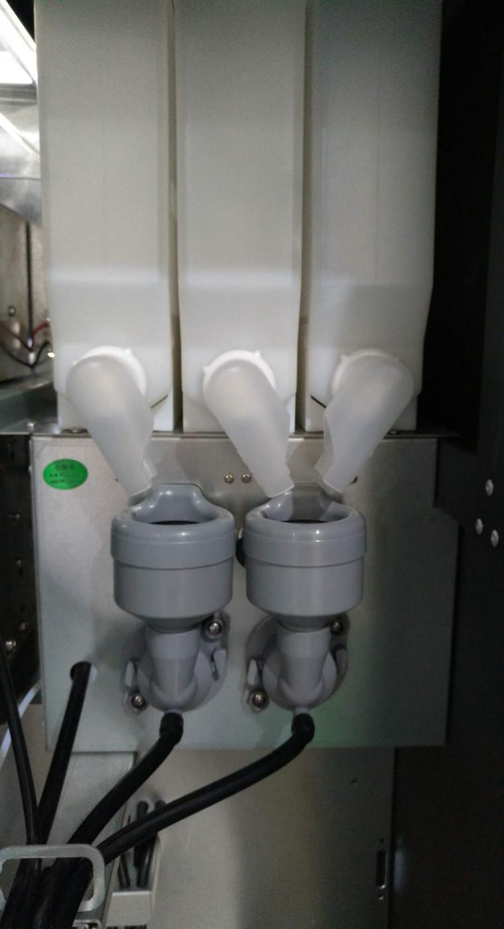

**45°**

|  |
| --- |
| Attention**:** |
| Contamination of the mixer is minimized when the cassette spout is placed correctly (at an angle of about 45 degrees). and dried before use.  Please pay attention to the direction when installing and maintaining the nozzle with  left and right notches. Please clean up the powder nozzle when there is a residue of powder accumulation. |

**Take out the instant material box:**

1.Lift the cassette upwards by 5 mm;

2.Withdrawal of the cassette to the outside;

3.Emptying the cassette;

4.The cassette is removable for cleaning;

5.After cleaning the cassette, the cassette needs to be dried.

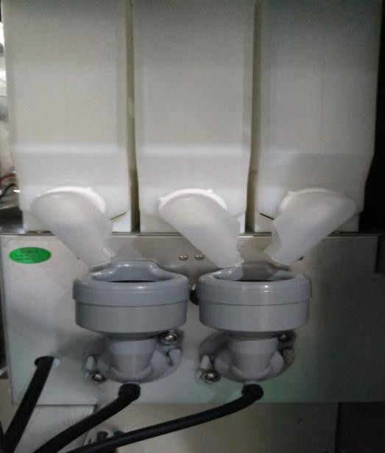

### 9.6.3 Cleaning the agitator

The position of the stirrer is as follows.

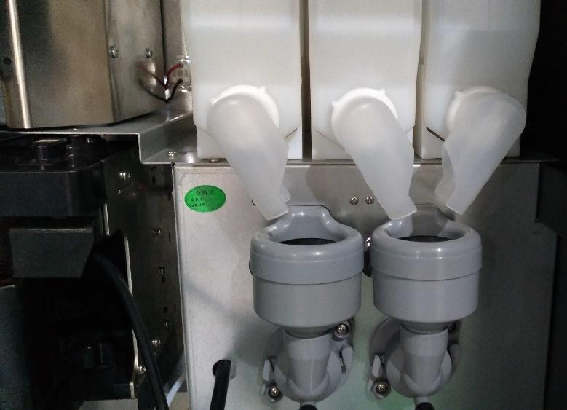

**Disassembly of the mixer**

1. Pinch the mixer and gently pull it outward, then pull it upward and out of the mixing chamber;

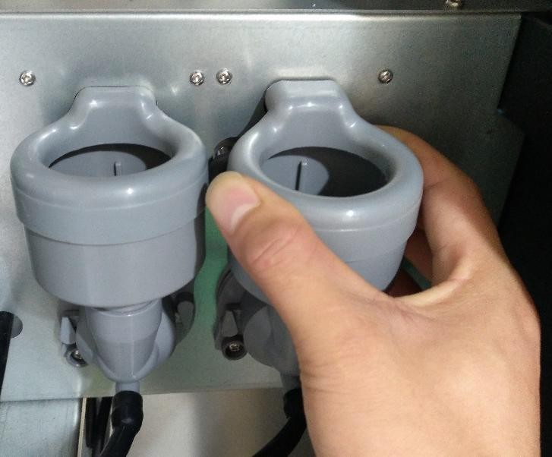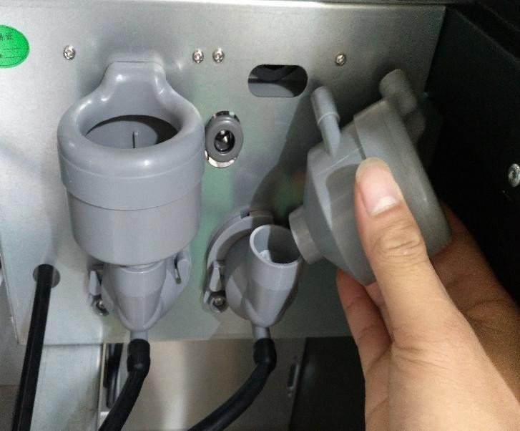

2. the mixer spout clockwise twist 90 degrees, pull off;

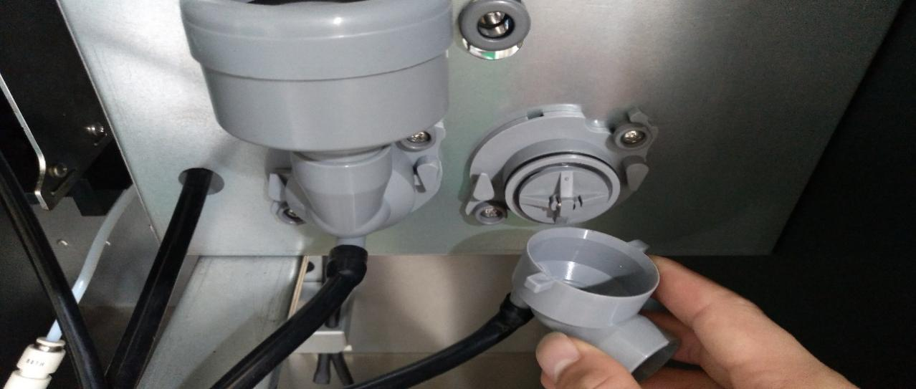

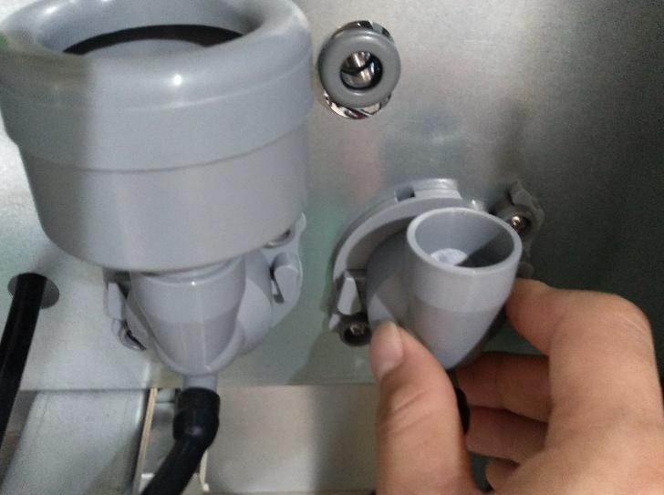

3. Separate the mixer body from the top cover;

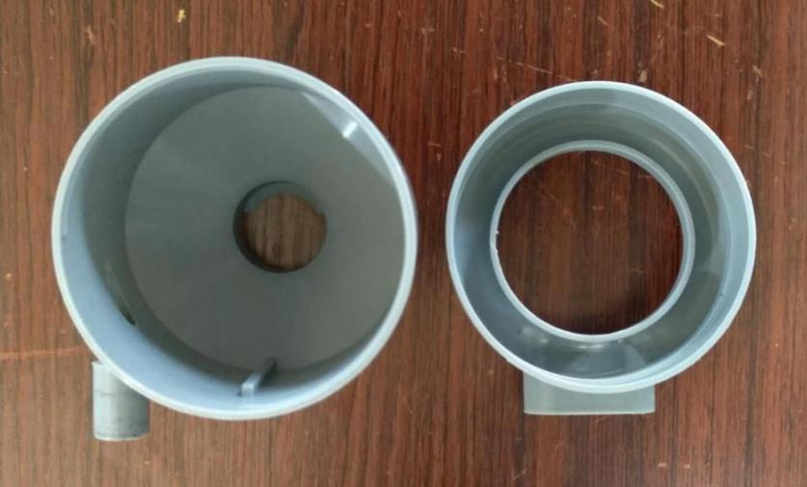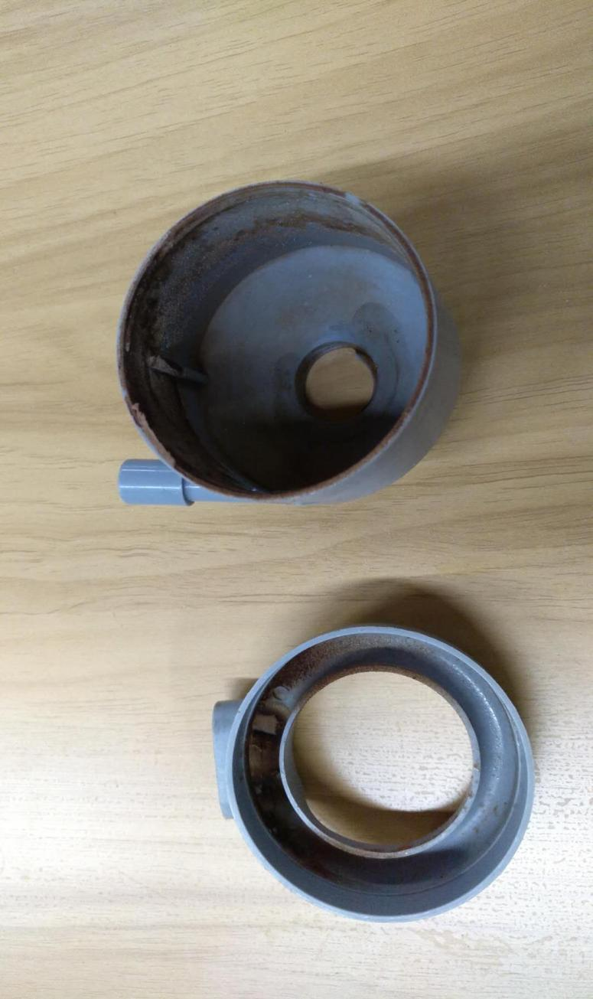

4.Cleaning the internal residual powder.

|  |
| --- |
| Attention**:** |
| An agitator will not leak only when it is installed correctly. The cleaning of the mixer needs to be carried out according to the actual situation, once a week or 200 cups need to be cleaned when there is a residue of powder accumulation inside the mixer, please clean up in time. |

### 9.6.4 Clean drink spout and holder

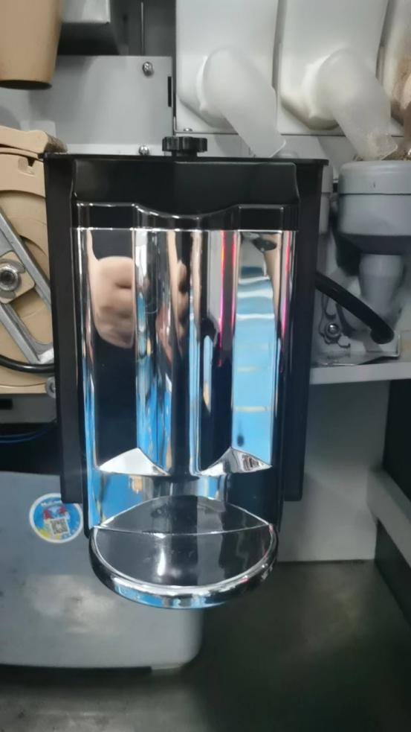

1. Turn the black fixation knob

### 9.6.5 Clean coffee brewer

|  |
| --- |
| Attention**:** |
| The maintenance and cleaning of coffee brewers is extremely important.  The only way to ensure the stable operation of a coffee brewer is to maintain it in accordance with the requirements. |

1.Cleaning requires the coffee brewer to be disassembled;

2.The coffee brewer is located as follows.

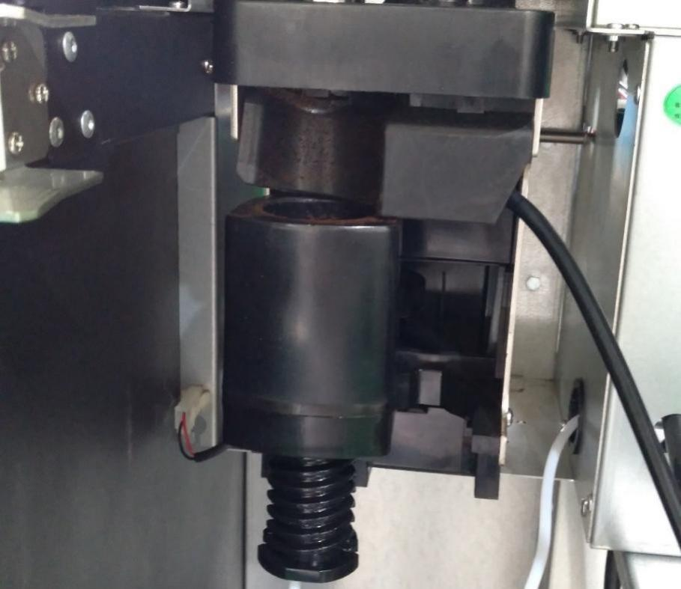

**PTC** heater connector

**Disassembly of coffee brewer**

1.Unplug the PTC heater connector (connector position is in the lower left corner) ;

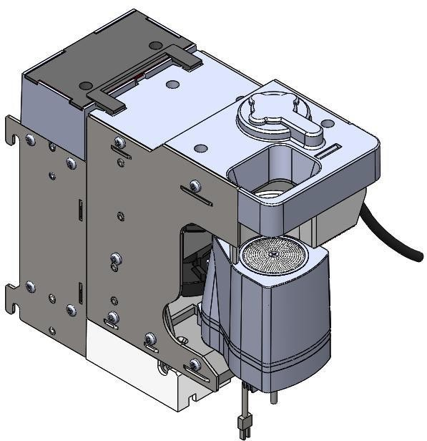

**PTC** heater connector

2.Pull out the white tube (positioned at the bottom);

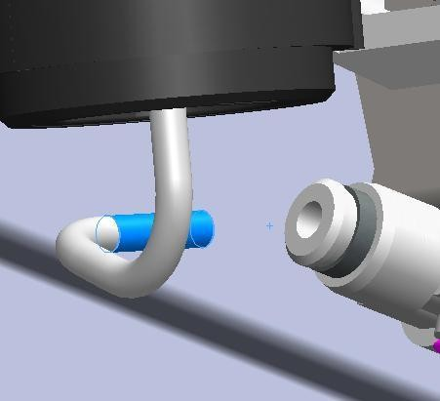

Step 1: Press your finger on the white quick connector in this position No release, confirm that the elastic space has been compressed

Step 2: Pull out the tube with force

3.Pull out the upper right corner of the outlet pipe (gently rotate the connector to the left 90 degrees and then pull it down);

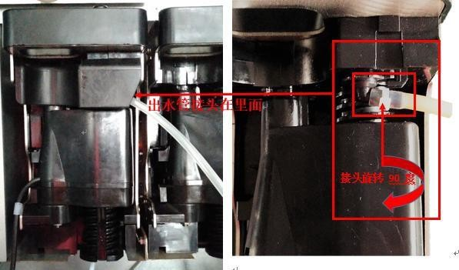

Joint rotated 90 degrees

The outlet pipe connector is inside

4.Lift the black snap knob up and then turn it left and press down hard until the bottom;

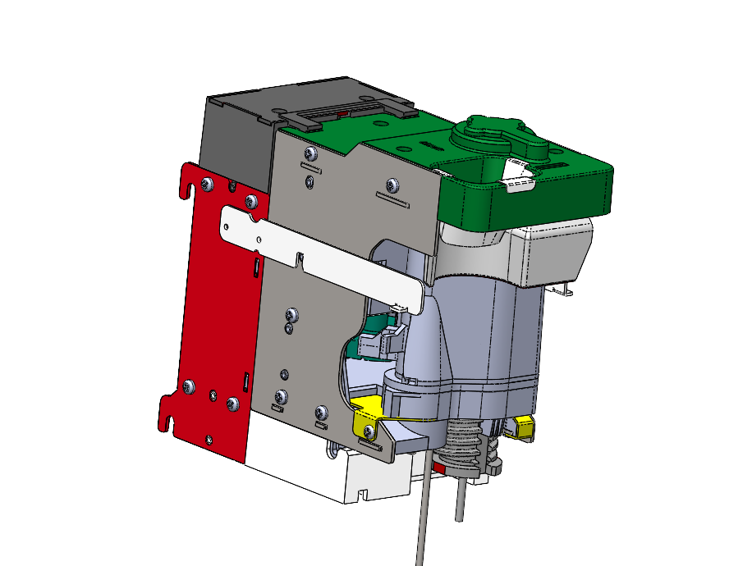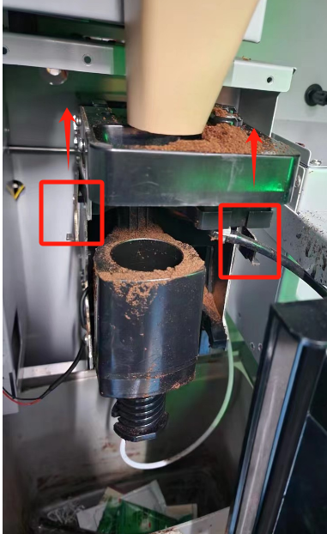

5.Tilt the coffee brewer to the front and pull it out;

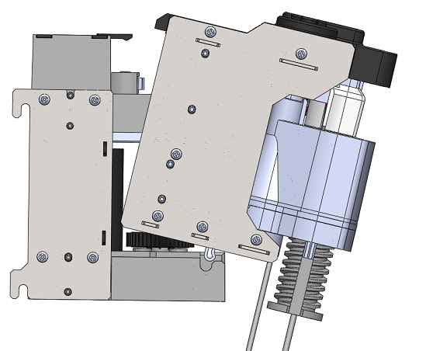

6. Draw out the entire coffee brewer.

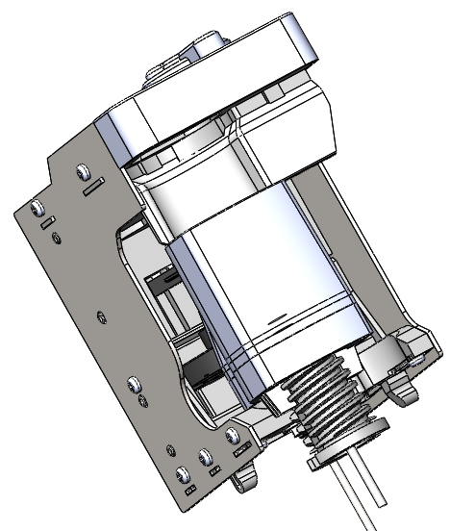

#### 9.6.5.1 Cleaning the coffee brewer inside the machine

1.After entering the machine management backend with the password 2020, click on the "Machine" icon in the bottom-left corner to enter the coffee brewer control interface;

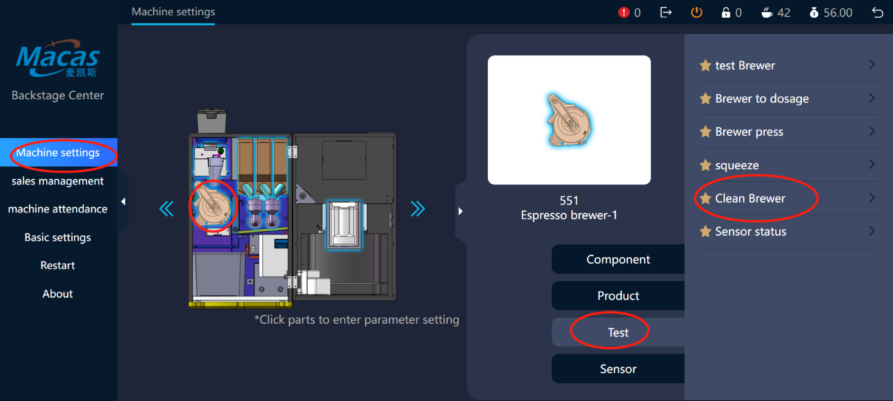

2.Click on the "Brewer to dosage" on the right side of the coffee brewer, the brewing chamber of the brewer will automatically go to the coffee powder receiving position;

3.Click "Squeeze" on the right side of the coffee brewer, the coffee brewer piston will move to the top squeeze position

Wipe the contaminated area of the brewer with a rag or brush;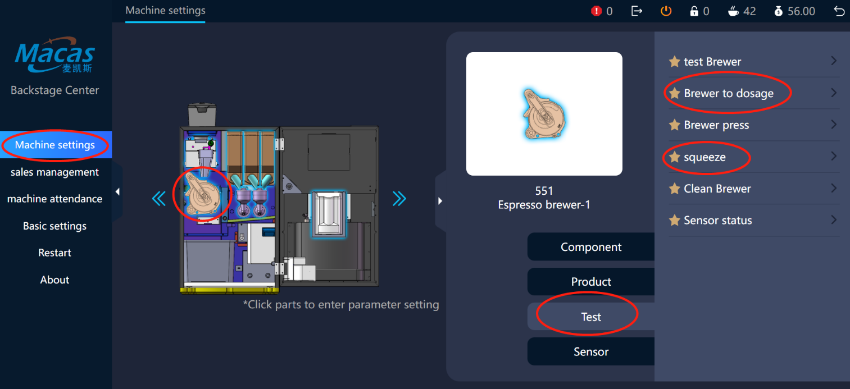

4.Pinch the nozzle and the silicone tube connection area and rotate 90 degrees outward, after feeling the bump, pull out the coffee nozzle downward;

5.The upper right corner of the outlet pipe (gently rotate the connector to the left 90 degrees and then pull it down).

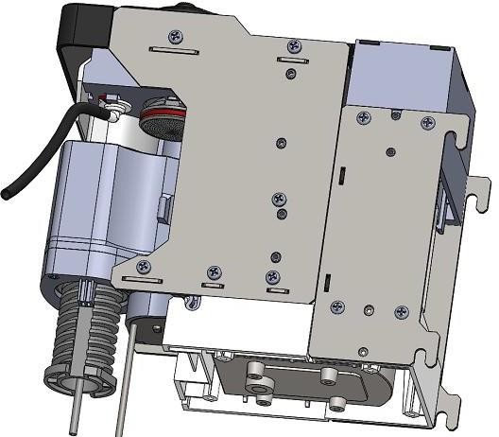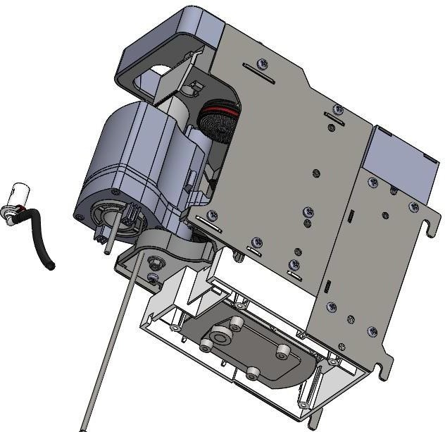

|  |
| --- |
| Attention: |
| Cleaning the brewer inside the machine needs to be done according to the actual situation, under  normal circumstances the brewer is contaminated very little! |

#### 9.6.5.2 Deep cleaning of coffee brewer (disassembly)

1.Removing the coffee brewer from the machine;

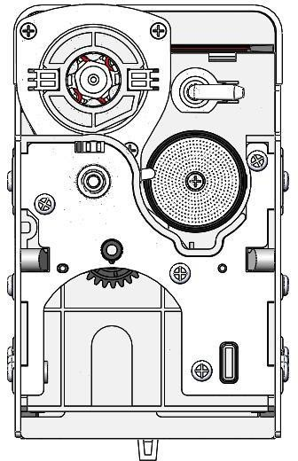

Filter and its

fixing screw

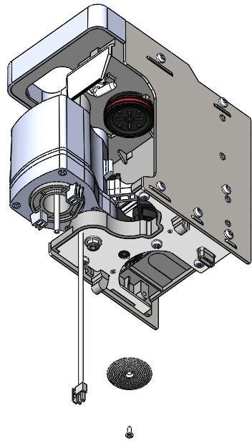

2.Remove the screws from the center of the filter;

3.Remove the screen, pay attention to the mesh whether some are blocked, if blocked, you need to brush scrub clean

Rinse the removed filter;

4.Remove the screw in the center of the bottom filter;

5.Take out the filter and the black plastic sheet for cleaning.

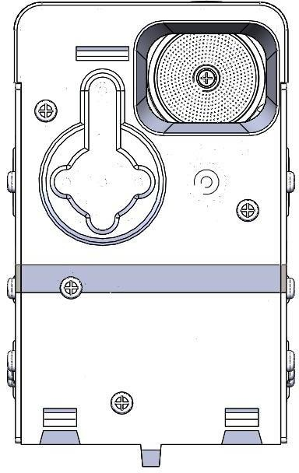

**Strainer and its fixing screw**

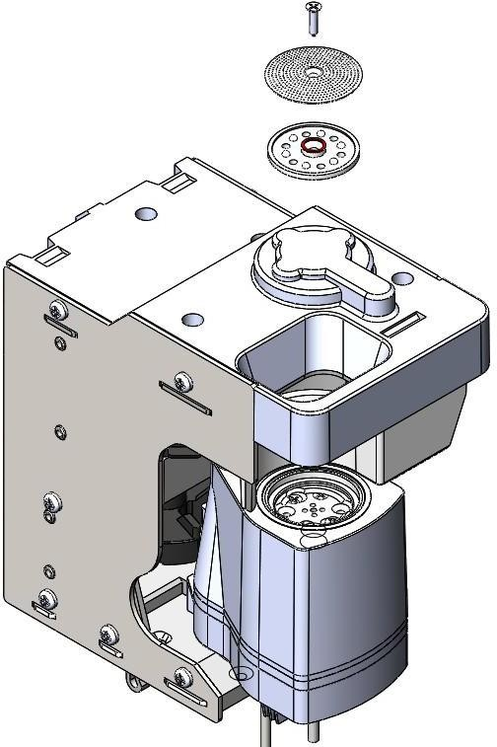

|  |
| --- |
| Attention**:** |
| Deep cleaning of the brewer needs to be done at 5000 cups or once every six months! |

#### 9.6.5.3 Coffee brewer descaling

1.Removing the coffee brewer;

2.Soak the brewer in the detergent solution;

3.After 30 minutes, clean the brush with water and wipe;

4.Place the brewer in a dry place to dry and return it to the machine after 24 hours.

|  |
| --- |
| Attention**:** |
| Cleaning and maintenance treatment is required every 2 weeks or 500 brewings  25,000 brews per year or 25,000 brews per year, requires trained personnel to replace wear parts  3 years or 100,000 brews, brewer and drive can be refurbished by McKays if needed  The maintenance and cleaning of coffee brewers is extremely important.  The only way to ensure the stable operation of a coffee brewer is to maintain it in accordance with the requirements. |

### 9.6.6 Cleaning the drip tray

|  |
| --- |
| Attention: |
| The coffee waste bin is recommended to use garbage bags for easy dumping.  When the waste water is full to a certain amount, empty it in time.  When installing the drip tray, make sure that the "full water detection signal wire" is positioned inside the waste water tray. |

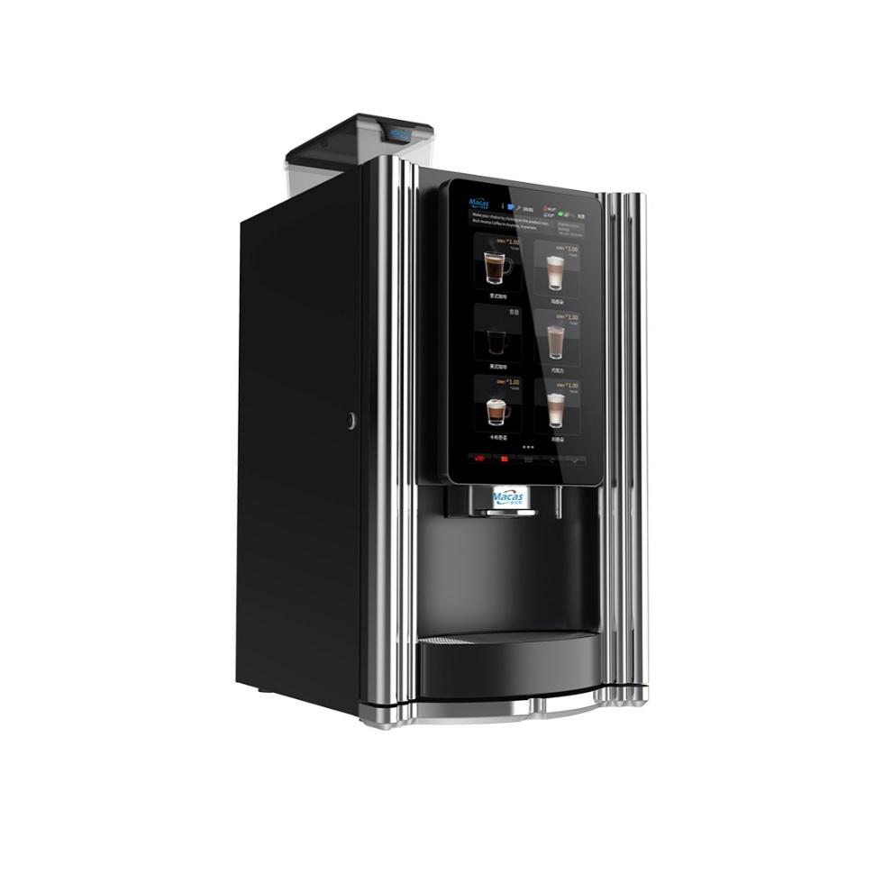

**Pull out the drip tray parallel**

### 9.6.7 Maintenance Guidelines

#### 9.6.7.1 Hot water system

If there is a problem with the hot water system, it is usually caused by valves, scale inside the boiler and accessories reaching the end of their life.

Maintenance of the water system requires removal of the hot water system from the machine.

Maintenance of the hot water system needs to be done by professional after-sales service personnel!

|  |
| --- |
| Beware**:** |
| Do not move or transport the machine extensively without doing the emptying of the boiler and the emptying of the small water tank! |

#### 9.6.7.2 Emptying the boiler and emptying the water tank

|  |
| --- |
| Beware**:** |
| Be aware of the risk of burns when emptying the boiler and emptying the water tank!  There is no risk of icing over short distances and the machine only needs to do the emptying of the water tank!  Long time out of use or outdoor transport, there is a risk of icing, the need to empty the boiler operation! |

**Emptying the boiler and emptying the water tank**

1.Pull out the bucket pumping tube;

2.Open the machine door (password:2020);

3.Place the trash can at the beverage outlet for waste water;

4.Click on the "Boiler Drain" or "Empty Tank" option;

5.After waiting 3 minutes, turn off the machine.

Note:The steps for emptying the boiler and emptying the water tank are the same, the only difference is that the emptying object is different!

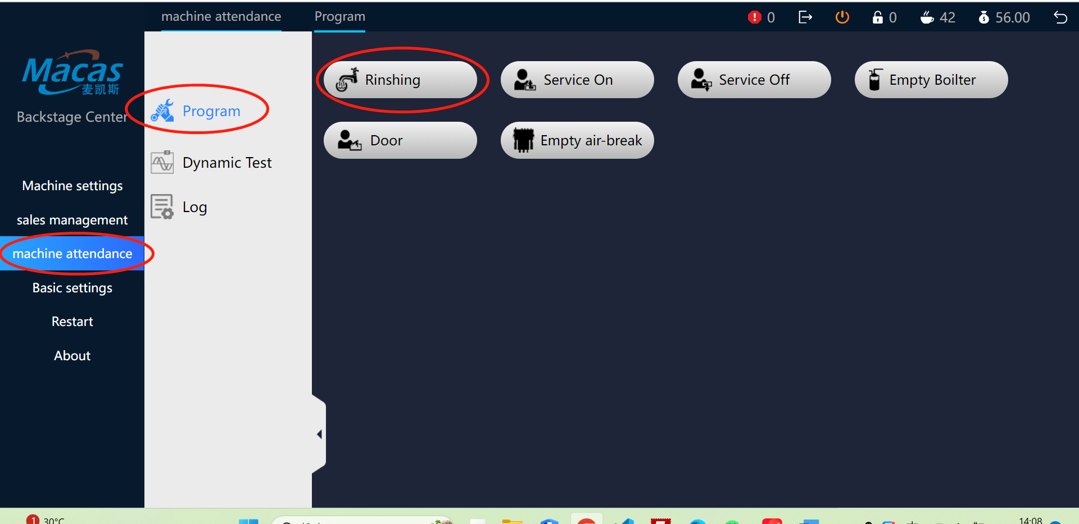

# 10 Procedures

## 10.1 System Backup

Currently, machine backup is not supported directly on the machine. However, you can use the backend backup files as an alternative.

## 10.2 System Upgrade

The machine needs to be upgraded remotely, please contact McKays after-sales service personnel, keep the machine network status, and need to have maintenance personnel at the machine site!

Note: U disk format must be FAT32 format

1.If upgrading with a USB stick, you must use the upgrade package debugged by a McKays technician;

2.Extract the upgrade package to the root of the USB drive;

3.Plug a USB stick into the USB port on the A40 core board while powered on;

4.Unplugging the USB drive after a black screen;

5.Press and hold the RST key on top of the A40 core board to reboot the core board;

6.The upgrade is successful when the machine is fully up.

## 10.3 System Recovery

Please contact McKays after-sales service to keep the machine networked, and a maintenance person needs to be present at the machine!

# 11 Machine Certification

|  |
| --- |
| European directives: |
| 2002/95/EC (RoHS) |
| 98/37/EC |
| 73/23/EC + 93/68/CE repealed by 2006/95/CE |
| 89/336/EC + 92/31/CE + 93/68/CE repealed by 2004/108/EC |
| 90/128/EC repealed by 2002/72/CE |
| 80/590/EEC and 89/109/EEC repealed by EC 1935/2004 |
| Harmonized standards Technical specifications: |
| CEI EN 60335-1 : 2002 + A11:20005 + A1:2005 + A12:2006 + A2:2006 |
| CEI EN 60335-2-75 : 2004 + A1:2005 + A11:2006 |
| EN 50366:2003 + A1:2006 |
| EN ISO 11201 and EN ISO 3744 |
| EN 55014-1 + A1 + A2 |
| EN 55022 + A1 + A2 |
| EN 55014-2 + A1 |
| EN 61000-3-2 |
| EN 61000-3-3 + A1 |
| EN 61000-4-2 + A1 + A2 |
| EN 61000-4-3 + A1 + A2 |
| EN 61000-4-4 + A1 |
| EN61000-4-5 + A1 |
| EN61000-4-6 + A1 |
| EN61000-4-11+ A1 |

**About CCC Certification**

Currently there is no national standard for vending coffee machines in the Chinese market, and McKays can only provide the machine's inspection report and the safety report of the relevant food contact parts!

# 12 List of frequently asked questions

|  |  |  |  |
| --- | --- | --- | --- |
| Problem Phenomenon | | Possible reasons | Solutions |
|  | Coffee flow is too slow | Coffee ground too fine | Adjusting the grinder (counterclockwise) |
| The amount of coffee powder is too large | Redoing the correction of the grinder |
| The filter on top of the brewer is scaled up | Descaling according to the instruction guide |
| Leakage in the pipeline | Re-plug after checking, or replace |
| Brewer with leaks | Replacement of wearing parts |
|  | Coffee flowing too fast | Coffee grind too coarse (pressure sensor feedback exceeds limit) | Adjust the grinder (clockwise) |
| The amount of coffee powder is too small | Redoing the correction of the grinder |
|  | Product is grayed out in the user interface and cannot be selected  Instant drinks taste light | No more coffee beans | With coffee beans |
| There is a problem with the electromechanical components associated with it | Go to the backend to check the error message |
| The outlet of the cassette is blocked, or not turned down after cleaning | Inspection, cleaning, correction |
| Powder filling error | Check, correct |
| Product is grayed out in the user interface and cannot be  selected | | Wrong recipe setting | Upgrade recipe settings |
| The spout of the cassette is not in the correct position | Check, correct |
| Inaccurate dose | Re-alignment of the magazine |
| Incorrect parameter, powder discharge | Motor speed increases, powder |
|  | | Brewer leaks | Check and inform the after-sales service |
| Leakage in the pipe connecting the brewer | Re-plug, confirm |
| The brewer's seal is at the end of its life | Replacement |
| Incorrect flow meter pulse count | Reset |
| First time using the machine, there is air in the pipe | Reboot and retry more than 3 times |
| The machine does not come out of the two- dimensional code | | Poor network signal | Replace the signal card of other carriers |
| 4G Card Default | Contact McKays after-sales service |
| Backend server exception problem | Contact McKays after-sales service |
| Boiler filling failure | | This time using the machine, the pipe has air | Power off for two minutes to start again |